28 February 2022

Dear Parent/Guardian

I am now able to give you further information in respect of the Appeals process for admissions to Year 7 at St Aidan’s in September 2022. The Appeals information which you have requested is enclosed.

The completed form should be returned to:

Admission Appeals Office
North Yorkshire County Council
Room 12
County Hall
Northallerton DL7 8AD

The form should be returned to the above address as soon as possible but NOT LATER THAN TUESDAY 29 March 2022. If you return your form later than this date it may not be possible to hold your appeal until long after all the other appeals for St Aidan’s School have been determined. This could prejudice your chances of the appeal being successful.

Please note that all appeals for St Aidan’s Church of England School will be held remotely during normal office hours week commencing Monday 9th May 2022. If you decide to appeal and wish to attend to present your case please keep this timeframe free in your diary.

The Clerk of the Appeals Committee informs parents of the outcome of the hearing in writing after all the appeals have been considered.

Yours sincerely

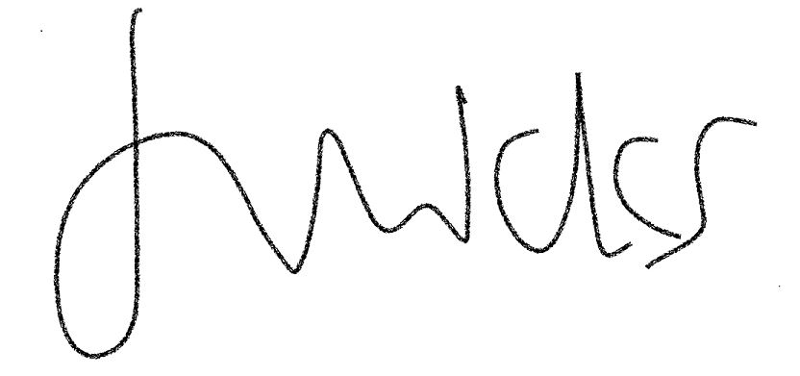
Mrs J Wicks
Chair of Governors

