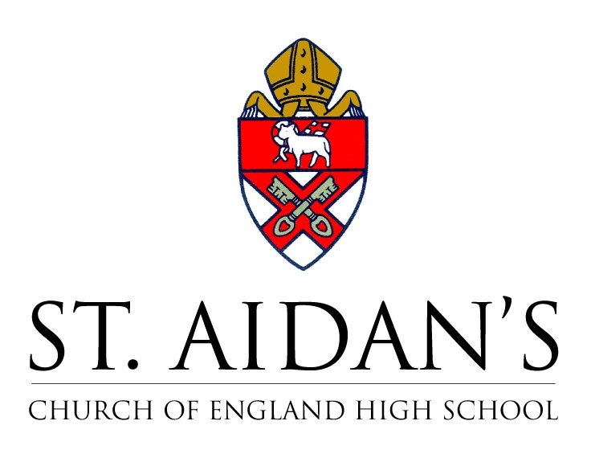

SUPPLEMENTARY INFORMATION FORM (SIF)

Please state the school year for which you are seeking admission Year (7/8/9/10/11) _______

Please note that this is not an application form. Application to St Aidan’s Church of England High School is made by the Common Application Form (CAF). Please note that this form is in ADDITION to the (CAF).

This form requests information relating to the oversubscription criteria at St Aidan’s Church of England High School. It will only be used to determine the allocation of places if the school is over subscribed.

We therefore recommend you complete this SIF and return it to St Aidan’s Church of England High School. It will be used as the basis for decision making by the Governors’ Admissions Sub-Committee. Decisions on admissions policy will not take into account the child’s ability, aptitude or present school in allocating places.

Details of Child

Christian/First Names Surname

Home address

at time of application Home Tel

Parental

Mobile No

Post Code

Parental

Email address DOB

For Office Use Only: | Date Received:
Ministers signature:

SEN | Looked After | Sibling | Staff
Social/Medical | Community | Other Faith | Distance
Foundation Harrogate | Foundation Ripon | Recorded
Accepted | Not Accepted | Withdrawn
Outside of Deaneries:

On what basis are you applying for a place at St Aidan’s Church of England High School:-
(You may apply for consideration under more than one criteria)

Are you applying for a Foundation Place (see Priority 3)  Are you applying for a Foundation Place (see Priority 8 out of area application)  Denomination/Religion: ______________________________________  Place of worship in the  religious tradition: _____________________________________________  Priest or Minister’s signature confirming the above  (Please be aware that the Governors will not be able to consider your application for a Foundation Place without a Church Leader’s signature)  St Aidan’s may contact Faith Leaders to confirm the above. In the event that the Faith Leader wishes to change the confirmed frequency of attendance this will be communicated to parents/carers by the school.  Note:- In the event that during the period specified for attendance at worship the church or, in relation to those of other faiths, relevant place of worship has been closed for public worship and has not provided alternative premises for that worship, the requirements of these admissions arrangements in relation to attendance will only apply to the period when the church or in relation to those of other faiths, relevant place of worship or alternative premises have been available for public worship.  Signature:- Dated:-  Name/Position:-  Contact Number:-  Email address:-  Address- Stamp if available:- | □Yes  □Yes
  In the last three years how often has your child attended a place of worship in the religious tradition?
  (See Appendix 1)
  Weekly 3 points
  2 – 3 times/month 2 points
  Monthly 1 point
  In the last three years how often has a parent or guardian, attended a place of worship in the religious tradition?
  (See Appendix 1)
  Weekly 3 points
  2 – 3 times/month 2 points
  Monthly 1 point

Is a parent of the child a member of staff at St Aidan’s Church of England High School? (See Priority 4) | □Yes

Do you wish your child to be considered on social or medical  grounds? (see Priority 5) | □Yes
Are you applying for a World Religion Place other than Christianity (see Priority 6)  Denomination/Religion: ______________________________________  Place of worship: _____________________________________________  Faith Leader’s signature confirming the above  (Please be aware that the Governors will not be able to consider your application for a World Religion place without a Faith Leader’s signature)  St Aidan’s may contact Faith Leaders to confirm the above. In the event that the Faith Leader wishes to change the confirmed frequency of attendance this will be communicated to parents/carers by the school..  Note:- In the event that during the period specified for attendance at worship the church or, in relation to those of other faiths, relevant place of worship has been closed for public worship and has not provided alternative premises for that worship, the requirements of these admissions arrangements in relation to attendance will only apply to the period when the church or in relation to those of other faiths, relevant place of worship or alternative premises have been available for public worship  Signature:- Dated:-  Name/Position:-  Contact Number:-  Email address:-  Address- Stamp if available:- | □Yes
  In the last three years how often has your child attended a place of worship in the religious tradition?
  (See Appendix 1)
  Weekly 3 points
  2 – 3 times/month 2 points
  Monthly 1 point
  In the last three years how often has a parent or guardian, attended a place of worship in the religious tradition?
  (See Appendix 1)
  Weekly 3 points
  2 – 3 times/month 2 points
  Monthly 1 point

Are you applying for an in area Community Place (see Priority 7) | □Yes
Are you applying for an out of area Community Place (see Priority 9) | □Yes

I/We confirm this application to be accurate at the time of writing.

Name of parent(s)/carer(s) …………………………………………………………………………………..

Signed …………………………………….……………………………………………..

Date …………………………………………………

This form is made available to the Appeals Panel in the case of any appeal against non-admission. In all other respects the information given is treated in confidence. If you have any difficulty completing the form please do not hesitate to contact the Headteacher or the Admissions Team at the school.

Please return this form to: The Chair of Governors
Admissions
St Aidan’s Church of England High School
Oatlands Drive
Harrogate HG2 8JR

Closing Date:
(For Year 7 applications this is 31st October of their Year 6 academic year)

Please do get in touch with the Admissions Team at school if you have any queries or would like any clarification about this process.

YCST is the Data Controller for the purposes of the General Data Protection Regulation (GDPR) (Regulation (EU) 2016/679) and all information provided is held and controlled strictly in accordance with GDPR.
Further information can be found in the Trust’s GDPR Privacy Notice which is available on the Trust and School Websites and from school offices. Further information on data protection and GDPR can be found on the Information Commissioner’s Office Website at https://ico.org.uk/

Part of Yorkshire Causeway Schools Trust, a charitable company limited by guarantee registered in England and Wales with company number: 07663935

