MCQ E

1 Aluminium and copper are often used to make coins but iron is not.
Which statement explains this?
A Iron is above both aluminium and copper in the reactivity series.
B Iron is more expensive to manufacture than aluminium or copper.
C Iron is rarer than both aluminium and copper.
D Iron reacts with water.

Your answer

2 In the electrolysis of molten aluminium oxide for the extraction of aluminium, the following three reactions take place.
1 Al³⁺ + 3e⁻ → Al
2 2O²⁻ → O₂ + 4e⁻
3 C + O₂ → CO₂
Which reactions take place at the positive electrode?
A 1 only
B 2 only
C 1 and 3 only
D 2 and 3 only

Your answer

3 Which two substances are removed from the bottom of the blast furnace?
1 coke
2 iron
3 limestone
4 slag
A 1 and 3
B 1 and 4
C 2 and 3
D 2 and 4

Your answer

4 Which gas is most likely to react with limestone?
A ammonia
B carbon monoxide
C methane
D sulfur dioxide

Your answer

5 The diagram shows the structure of an ester
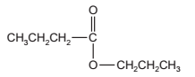
What are the starting materials for making this compound?
A butanol and butanoic acid
B butanol and propanoic acid
C propanol and butanoic acid
D propanol and propanoic acid

Your answer

6 Which information is correct regarding the formation of ethanol by the process of fermentation?
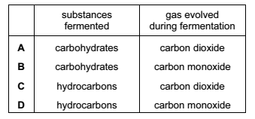

Your answer

7 Which partial structure is correct for the product of polymerisation of butene, CH₂=CHCH₂CH₃?
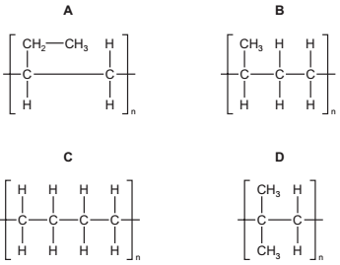

Your answer

8 Which molecule contains three shared pairs of electrons between two of its atoms?
A CO₂
B C₂H₄
C H₂O
D N₂
Your answer

9 Glucose is a simple sugar. Glycine is an amino acid.
In the diagram, which two arrows correctly show the hydrolysis products of a carbohydrate and of a protein?
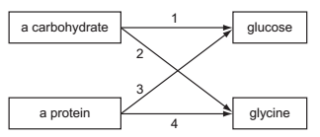
A 1 and 3
B 1 and 4
C 2 and 3
D 2 and 4

Your answer

10 When crude oil is distilled several products are obtained.
What is the correct order of their boiling points?
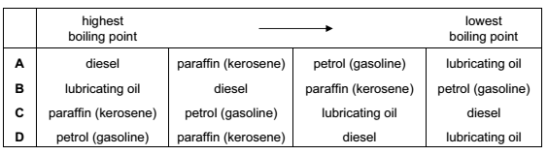

Your answer

11 The fractional distillation apparatus shown is being used to separate a mixture of two liquids. A thermometer is missing from the apparatus.
Where should the bulb of the thermometer be placed?
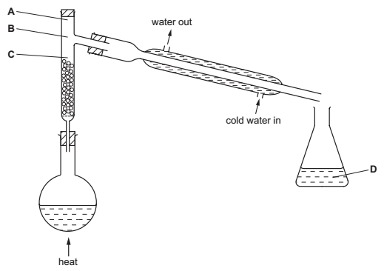

Your answer

12 The table shows the results of two reactions of an aqueous solution of a salt.
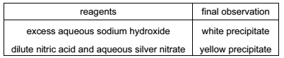
What is the name of the salt?
A calcium chloride
B calcium iodide
C zinc nitrate
D zinc sulfate

Your answer

13 Limestone reacts with hydrochloric acid.
Changing which reaction condition does not affect the rate of reaction?
A concentration of the acid
B limestone particle size
C pressure
D temperature

Your answer

14 A particle contains 34 protons, 45 neutrons and 36 electrons.
Which symbol is correct for this particle?

Your answer

15 What happens when sodium chloride melts?
A Covalent bonds in a giant lattice are broken.
B Electrons are released from atoms.
C Electrostatic forces of attraction between ions are overcome.
D Molecules are separated into ions.
Your answer

16 Which compound contains only eight covalent bonds?
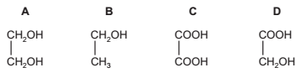

Your answer

17 A gas cylinder is placed in each of the four corners of a square room. Each cylinder
contains a different gas stored under the same pressure. The gases are released at exactly the same time.
Which gas will reach the centre of the room first?
A ammonia, NH₃
B argon, Ar
C carbon monoxide, CO
D chlorine, Cl₂
Your answer

18 Powdered calcium carbonate reacts with dilute hydrochloric acid to produce calcium chloride, water and carbon dioxide.
Which is the correct ionic equation, including state symbols, for this reaction?
A CaCO₃(s) + 2HCl(aq) → CaCl₂(aq) + H₂O(l) + CO₂(g)
B Ca²⁺(aq) + CO₃^{2–}(aq) + 2H⁺(aq) → Ca²⁺(aq) + H₂O(l) + CO₂(g)
C CO₃^{2–}(aq) + 2H⁺(aq) → H₂O(l) + CO₂(g)
D CaCO₃(s) + 2H⁺(aq) → Ca²⁺(aq) + H₂O(l) + CO₂(g)
Your answer

19 What is the relative molecular mass, M_{r}, of CuSO₄.5H₂O?
A 127 B 160
C 178 D 250

Your answer

20 1.00 dm³ of ammonia gas is passed over heated copper(II) oxide.
3CuO(s) + 2NH₃(g) → 3Cu(s) + N₂(g) + 3H₂O(l)
What is the volume of nitrogen formed when measured at the same temperature and pressure as the ammonia?
A 0.25 dm³
B 0.50 dm³
C 1.00 dm³
D 2.00 dm³

Your answer

21 What are the correct anode (positive electrode) and cathode (negative electrode) products when aqueous copper(II) sulfate is electrolysed using copper electrodes?

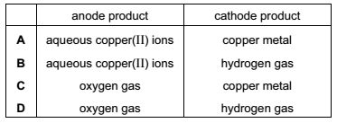

Your answer
22 Concentrated aqueous sodium chloride is electrolysed using inert electrodes.
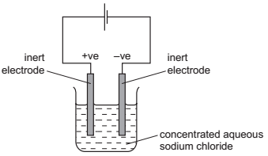

Which statement about this electrolysis is correct?
A Chloride ions travel through the solution to the negative electrode.
B Electrons travel through the solution to the sodium ions.
C Gases are given off at both electrodes.
D Sodium is formed at the negative electrode.

Your answer

23 The diagram shows the energy profile of a chemical reaction. Two energy changes are labelled X and Y.
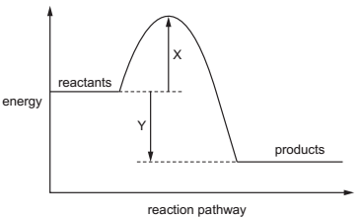
Which statement about the reaction is correct?
A The activation energy of the reaction is X + Y.
B The enthalpy change of the reaction is X.
C The enthalpy change of the reaction is X + Y.
D The reaction is exothermic.

Your answer

24 The equation shows a redox reaction between iron(II) chloride and chlorine gas.
2FeCl₂ + Cl₂ → 2FeCl₃
Which equation describes the reduction process in this reaction?
A 2Cl⁻ → Cl₂ + 2e⁻
B Cl₂ + 2e⁻ → 2Cl⁻
C Fe²⁺ → Fe³⁺ + e⁻
D Fe³⁺ + e⁻ → Fe²⁺

Your answer

25 In the graph, curve 1 was obtained by observing the decomposition of 100cm³ of
1.0 mol/dm³ hydrogen peroxide solution, catalysed by manganese(IV) oxide.
2H₂O₂ → 2H₂O + O₂
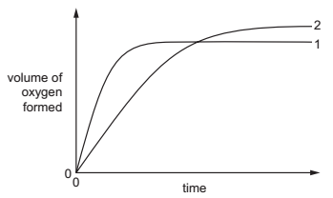
Which alteration to the original experimental conditions would produce curve 2?
A adding some 0.1mol/ dm³ hydrogen peroxide solution
B lowering the temperature
C using less manganese(IV) oxide
D using a different catalyst

Your answer

26 Which substance is insoluble in water?
A ammonium carbonate
B ammonium nitrate
C calcium carbonate
D calcium nitrate

Your answer

27 In which of these equilibria is the forward reaction favoured by an increase in
pressure?
A 2HI(g) → H₂(g) + I₂(g)
B N₂O₄(g) → 2NO₂(g)
C 2NO(g) + O₂(g) → 2NO₂(g)
D PCl₅(g) → PCl₃(g) + Cl₂(g)

Your answer

28 The Contact process, the Haber process and the hydrogenation of fats all involve the
use of a catalyst.
Which row correctly describes whether the catalyst used in each process is an element or a compound?
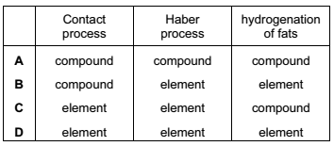

Your answer
29 Which element is sodium?

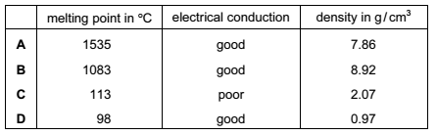

Your answer

30 A non-metal element forms oxides of the type XO₂ and XO₃.
What is X?
A aluminium
B carbon
C hydrogen
D sulfur
Your answer

