MCQ D

1 In which pair do neither of the gases change the colour of damp blue litmus paper?
A ammonia and hydrogen
B ammonia and hydrogen chloride
C carbon dioxide and chlorine
D carbon dioxide and sulfur dioxide

Your answer

2 Naturally-occurring bromine has a relative atomic mass of 80 and consists entirely of two isotopes of relative atomic masses 79 and 81.
What can be deduced about naturally-occurring bromine from this information only?
A Bromine contains the two isotopes in equal proportions.
B Bromine has different oxidation states.
C Bromine isotopes have different numbers of protons.
D Bromine is radioactive.
Your answer

3 Which compound has molecules each of which contains only two covalent bonds?
A CH₄
B H₂O
C MgCl₂
D Na₂O

Your answer

4 An ionic bond is formed by
A electron sharing between metals and non-metals.
B electron sharing between non-metals.
C electron transfer between non-metals.
D electron transfer from metals to non-metals.

Your answer

5 Both magnesium oxide, MgO, and aluminium oxide, Al₂O₃, are solids at room
temperature, 25°C.
MgO has a melting point of 2852°C and a boiling point of 3600°C.
Al₂O₃ has a melting point of 2072°C and a boiling point of 2880°C.
Over which temperature range will both pure compounds conduct electricity?
A 25 to 2852°C
B 2072 to 2852°C
C 2852 to 2880°C
D 2880 to 3600°C
Your answer

6 Which substance conducts an electric current but remains chemically unchanged?
A aluminium
B aqueous sodium chloride
C molten lead(II) bromide
D pure ethanoic acid

Your answer

7 Which statement most clearly indicates that diamond and graphite are forms of
carbon?
A Both are crystalline solids.
B Complete combustion of equal masses of both solids produces equal masses of
carbon dioxide as the only product.
C Graphite conducts electricity whereas diamond is an insulator.
D Under suitable conditions graphite can be partially converted into diamond.

Your answer

8 In an experiment, 1cm³ of a gaseous hydrocarbon X required 4cm³ of oxygen for
Complete combustion to give 3cm³ of carbon dioxide. All gas volumes are measured at r.t.p.
Which formula represents X?
A C₂H₂
B C₂H₄
C C₃H₄
D C₃H₈
Your answer

9 What is the concentration of a solution containing 1.0g of sodium hydroxide in 250cm³ of solution?
A 0.025 mol/dm³
B 0.10 mol/dm³
C 0.25 mol/dm³
D 1.0 mol/dm³

Your answer

10 Which gas could be used to convert copper(II) oxide to copper?
A carbon dioxide
B hydrogen
C nitrogen
D oxygen

Your answer

11 Aluminium reacts with chromium(III) oxide as shown.
aluminium + chromium(III) oxide → chromium + aluminium oxide
Which statements are correct?
- Aluminium is more reactive than chromium.
- A similar reaction would also take place between aluminium and iron(III) oxide.
- Iron(III) oxide is reduced by another metal in the blast furnace.
A 1, 2 and 3
B 1 and 2 only
C 1 and 3 only
D 2 and 3 only

Your answer

12 Using the Periodic Table for the relative atomic masses, which has the least mass?
A 0.1 moles of silicon dioxide, SiO₂
B 0.5 moles of oxygen, O₂
C 0.5 moles of lithium, Li
D 1.0 moles of ammonia, NH₃

Your answer

13 The diagram shows how an underwater iron pipe can be protected from rusting.
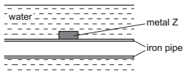

Metal Z can be ......1...... because it is ......2...... reactive than iron.
Which words correctly complete gaps 1 and 2?

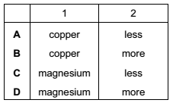

Your answer

14 Brass is an alloy.
Which statement about brass is correct?
A It contains a sea of electrons.
B It contains positive and negative ions which are free to move.
C It is a compound of a metal and a non-metal.
D It is a compound of two or more metals.

Your answer
15 Which item is made from mild steel?
A a car body
B a container to store gas in a chemical plant
C a scalpel for use in an operating theatre
D a set of cutlery

Your answer

16 The table shows the composition of exhaust gases from an internal combustion engine.
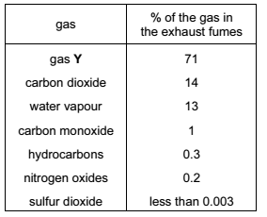
What is gas Y?
A ammonia B argon
C chlorine D nitrogen

Your answer

17 Which two gases do not damage limestone buildings?
A nitrogen and carbon monoxide
B nitrogen dioxide and carbon monoxide
C nitrogen dioxide and carbon dioxide
D sulfur dioxide and carbon dioxide

Your answer

18 Iron(III) oxide can be reduced to iron by carbon.
Which other element can reduce iron(III) oxide to iron?
A copper B lead
C magnesium D silver

Your answer

19 Which is a correct definition of isomers?
A atoms with the same relative atomic mass and different structures
B compounds with the same molecular formula and different structures
C compounds with the same molecular mass and different structures
D elements with the same molecular mass and the same structures

Your answer

20 Two esters have the same molecular formula, C₃H₆O₂.
What are the names of these two esters?
1 methyl ethanoate
2 ethyl propanoate
3 ethyl methanoate
4 propyl methanoate
A 1 and 2 B 1 and 3
C 2 and 4 D 3 and 4

Your answer

21 When cracked, one mole of a compound, X, produces one mole of propene and one
mole of hydrogen.
X → C₃H₆ + H₂
What type of compound is X?
A an alcohol
B an alkane
C an alkene
D a carboxylic acid

Your answer

22 Which of the following has not been prepared by reacting a carboxylic acid with an alcohol?
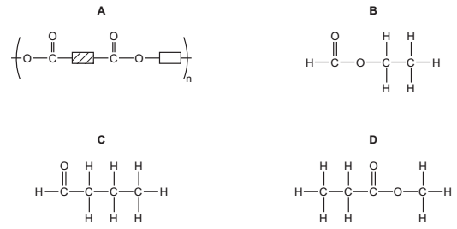

Your answer

23 Which of these polymers is a protein?
A (C₂H₃Cl)_{n}
B (C₅H₈O₂)_{n}
C (C₆H₁₀O₅)_{n}
D (C₂H₃NO)_{n}

Your answer

24 In the addition polymer poly(propene), what is the simplest ratio of carbon atoms to
hydrogen atoms?
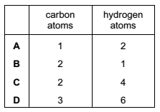

Your answer

25 Which is an anion that is present in the solution formed when an excess of dilute hydrochloric acid is added to calcium carbonate?
A Ca²⁺
B Cl⁻
C CO₃²⁻
D H⁺

Your answer

26 A mixture containing equal volumes of two liquids that mix completely but do not react together is placed in the apparatus shown and heated until the thermometer first shows a steady reading.
At which position will there be the highest proportion of the liquid with the higher boiling point?
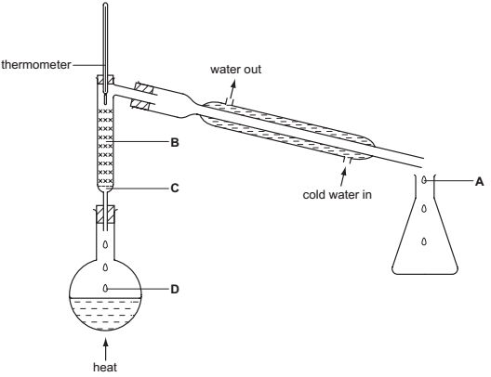

Your answer

27 Which pair of elements, when combined together, do not form a covalent compound?
A caesium and fluorine
B nitrogen and chlorine
C phosphorus and fluorine
D sulfur and chlorine

Your answer

28 The diagram shows the structure of a covalent compound containing the element hydrogen, H, and the unknown elements X, Y and Z.
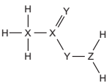
To which groups of the Periodic Table do these three elements, X, Y and Z, belong?

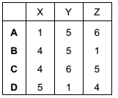

Your answer

29 A metal consists of a lattice of positive ions in a ‘sea of electrons’.
What changes, if any, take place to the electrons and positive ions in a metal wire when an electric current is passed through it?

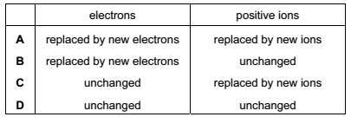

Your answer

30 What is the mass of one mole of carbon-12?
A 0.012g
B 0.024g
C 1 g
D 12g

Your answer

