MCQ C

1 Which salt can be prepared by an acid-alkali titration method?
A ammonium sulfate B copper(II) sulfate
C iron(II) sulfate D zinc sulfate

Your answer

2 The table shows properties of four chlorides.
Which is magnesium chloride ?
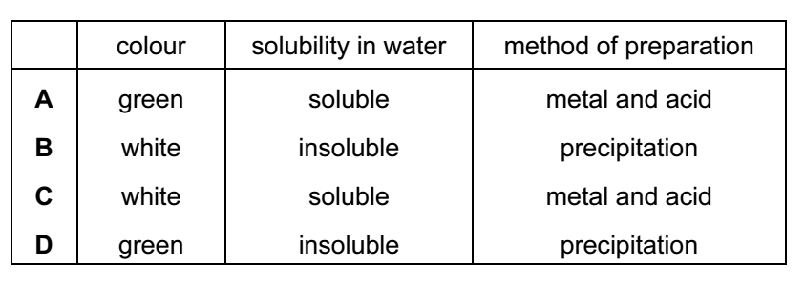
Your answer

3 Why is ethanoic acid described as a weak acid?
A It is only slightly ionised in water.
B It is a poor conductor of electricity.
C It is an organic acid.
D It reacts only with very reactive metals.

Your answer

4 Which pair of substances produce a precipitate when their aqueous solutions are
mixed?
A barium nitrate, silver nitrate
B sodium chloride, barium nitrate
C sodium nitrate, barium chloride
D sodium sulfate, barium chloride

Your answer

5 The diagram represents the manufacture of sulphuric acid by the Contact process.
R
Sulfur Sulfur dioxide Sulfur trioxide Sulfuric acid

What is used in step R?
A vanadium(V) oxide
B water only
C water followed by concentrated sulfuric acid
D concentrated sulfuric acid followed by water

Your answer
6 Rubidium, Rb, is an element in Group I of the Periodic Table.
Which statement about rubidium is correct?
A It reacts slowly with water.
B It forms an insoluble hydroxide.
C It is liberated at the cathode during the electrolysis of an aqueous solution of its chloride.
D It forms a sulfate, Rb₂SO₄

Your answer

7 A coil of clean copper wire is suspended in aqueous silver nitrate. Crystals of silver
are deposited on the copper wire.
Which statement is not correct?
A The copper is oxidised.
B The total mass of the crystals of silver increases gradually.
C The total number of positive ions in the solution is unchanged.
D The solution turns blue.
Your answer

8 Zinc and aluminium both react with dilute hydrochloric acid.
Why does zinc react more quickly than aluminium?
A Aluminium is lower than hydrogen in the reactivity series.
B Aluminium has an oxide coating.
C Zinc is an amphoteric element.
D Zinc is a transition metal.

Your answer

9 Which metal is used in the sacrificial protection of iron pipes?
A copper
B lead
C magnesium
D sodium

Your answer

10 Which of the following has not been prepared by reacting a carboxylic acid with an alcohol?
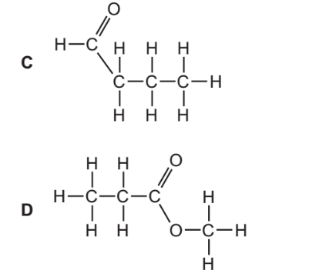

Your answer
11 Which compound is obtained by the oxidation of ethanol, C₂H₅OH?
A HCO₂CH₃
B C₂H₅CO₂H
C CH₃OH
D CH₃CO₂H

Your answer

12 Which statement applies to all three of the compounds ethane, ethene and ethanol?
A One molecule of each compound contains the same number of carbon atoms.
B One mole of each compound contains the same number of hydrogen atoms.
C They all occur in crude oil.
D They are all liquids at room temperature.
Your answer

13 What is the empirical formula of ethanoic acid?
A CH₂O
B CH₄O
C C₂H₃O
D C₂H₄O₂

Your answer

14 Which statement about all the noble gases is correct?
A The number of protons in the atoms equals the number of neutrons.
B Their atoms each have a stable arrangement of electrons.
C Their atoms each have eight electrons in their outer shell.
D They exist as molecules containing two atoms.
Your answer

15 A substance Q conducts electricity both when solid and molten.
What is Q?
A an alloy
B a hydrocarbon
C a metal oxide
D a salt

Your answer

16 The diagrams show the structures of two forms of carbon.

Which set of data is correct for these two structures?
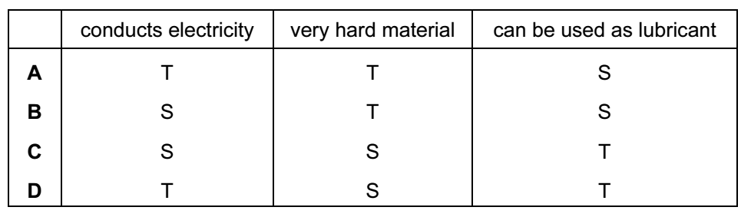

Your answer

17 Substance X has a melting point higher than 500ºC. It is insoluble both in water and in organic solvents. It conducts electricity when both solid and molten.
What is X?
A copper
B mercury
C poly(ethene)
D sodium chloride

Your answer

18 How many moles per dm³ of gaseous carbon dioxide are there if 4.4g occupies 500cm³?
A 0.1 mol/dm³
B 0.2 mol/dm³
C 2.2 mol/dm³
D 8.8 mol/dm³

Your answer

19 Which reactions take place during the electrolysis of aqueous copper(II) sulphate with copper electrodes?
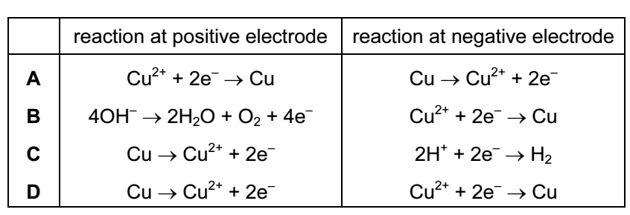

Your answer

20 The reaction C₂H₄ + 3O₂ → 2CO₂ + 2H₂O is exothermic because
A more bonds are broken than are formed.
B more bonds are formed than are broken.
C the energy needed to break the bonds is greater than that released on forming new bonds.
D the energy needed to break the bonds is less than that released on forming new bonds

Your answer

21 Chlorine can be manufactured by using the reversible reaction between hydrogen chloride and oxygen.
4HCl(g) + O₂(g) → 2H₂O(g) + 2Cl₂(g) ∆H is negative
A mixture in dynamic equilibrium is present at 450ºC.
Which change to the mixture will increase the amount of chlorine at equilibrium?
A adding a catalyst
B adding more HCl(g)
C decreasing the pressure
D increasing the temperature

Your answer

22 Which pair of substances produce a precipitate when their aqueous solutions are mixed?
A sodium chloride and barium nitrate
B sodium nitrate and barium chloride
C sodium nitrate and silver nitrate
D sodium sulfate and barium chloride

Your answer

23 Which statement about catalysts is correct?
A Catalysts are used in industry to reduce energy costs.
B Catalysts are used up during a reaction.
C Iron is used as a catalyst in the Contact Process.
D Transition metals do not make good catalysts.

Your answer

24 Element X is a solid at room temperature.
It needs one electron per atom to gain the electronic structure of a noble gas.
It is the least reactive element in its group.
What is the element X?
A At
B Cs
C F
D Li

Your answer

25 Elements X and Y are in Group VII of the Periodic Table.
X is a liquid at room temperature. Y is a solid at room temperature.
1 Atoms of Y have more protons than atoms of X.
2 Molecules of Y have more atoms than molecules of X.
3 Y displaces X from aqueous solutions of X- ions.
Which statements are correct?
A 1 only
B 2 only
C 3 only
D 1, 2 and 3

Your answer

26 Which gas cannot be removed from the exhaust gases of a petrol powered car by its catalytic converter?
A carbon dioxide
B carbon monoxide
C hydrocarbons
D nitrogen dioxide

Your answer

27 Aluminium sulfate can be obtained as shown in the equation.
2Al(OH)₃ + 3H₂SO₄ → Al₂(SO₄)₃ + 6H₂O
How many moles of sulfuric acid are needed to produce 0.5 mol of aluminium sulfate?
A 0.5 B 1.0
C 1.5 D 3.0

Your answer

28 Which graph shows the changes in pH as an excess of hydrochloric acid is added to aqueous sodium hydroxide?

Your answer
29 In which method of separation are R_{f} values used?
A chromatography
B crystallisation
C filtration
D fractional distillation

Your answer

30 The diagrams show the arrangement of particles in three solids: krypton, potassium
and sodium chloride.
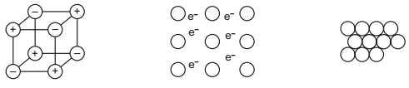

In which order are the solids shown?
A krypton; potassium; sodium chloride
B krypton; sodium chloride; potassium
C sodium chloride; krypton; potassium
D sodium chloride; potassium; krypton

Your answer

