MCQ B

1 Sulphur and selenium (Se) are in the same group of the Periodic Table.
From this, we would expect selenium to form compounds having the formulae
A SeO, Na₂Se and NaSeO₄.
B SeO₂, Na₂Se and NaSeO₄.
C SeO₂, Na₂Se and Na₂SeO₄.
D SeO₃, NaSe and NaSeO₄.

Your answer

2 X and Y are diatomic elements. X is less reactive than Y.
What are elements X and Y?
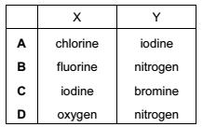

Your answer

3 A metal X, in Group I of the Periodic Table, would be expected to
A form a nitrate of formula X(NO₃)₂.
B form an acidic oxide.
C form an insoluble chloride.
D produce hydrogen from cold water.

Your answer

4 Four test-tubes were set up as shown.
Each piece of iron was protected on one side by a different coating.
In which test-tube is the iron least likely to rust?
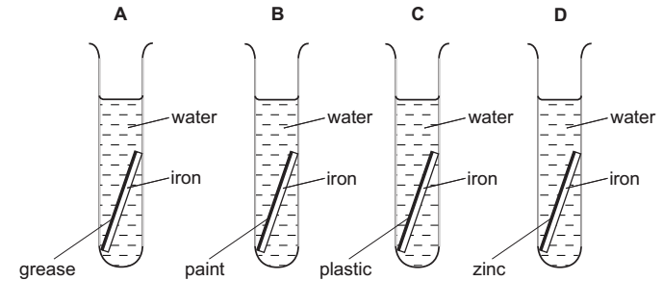

Your answer

5 Aluminium is used to make saucepans because of its apparent lack of reactivity.
Which property of aluminium explains its unreactivity ?
A It has a high electrical conductivity.
B It has a low density.
C It has a surface layer of oxide.
D It is in Group 3 of the Periodic Table.

Your answer

6 A solid substance Z burns in air to form a product that is gaseous at 20°C.
What is Z?
A hydrogen
B carbon monoxide
C carbon
D magnesium

Your answer

7 Carboxylic acids react with alcohols to form esters.
Which acid and alcohol react together to form the following ester?
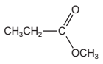
A propanoic acid and ethanol
B propanoic acid and methanol
C ethanoic acid and ethanol
D ethanoic acid and methanol

Your answer

8 Which two compounds are members of the same homologous series?
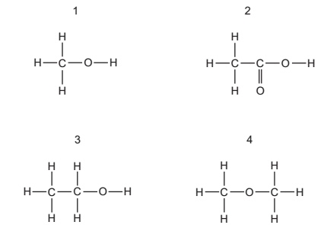
A 1 and 2
B 1 and 3
C 1 and 4
D 2 and 4

Your answer
9 Which compound has more than two carbon atoms per molecule?
A ethyl ethanoate
B ethene
C ethane
D ethanoic acid

Your answer

10 Alkanes are a homologous series of organic compounds.
Which statement about alkanes is correct?
A Their boiling points increase as the length of the carbon chain increases.
B Their general formula is C_{n}H_{2n}.
C They are unsaturated hydrocarbons.
D They take part in addition reactions.

Your answer

11 Which property of a gas affects the rate at which it spreads throughout a laboratory?
A boiling point
B molecular mass
C reactivity
D solubility in water

Your answer

12 Which pair of substances are both mixtures?
A air; water
B limewater; water
C sea-water; air
D sea-water; ethanol

Your answer

13 In which substance is each carbon atom covalently bonded to only three other atoms?
A carbon dioxide
B diamond
C graphite
D methane
Your answer

14 In which pair of substances does each have a giant molecular structure?
A diamond, iodine
B diamond, silica (sand)
C iodine, methane
D methane, silica (sand)

Your answer

15 How does a magnesium atom form a bond with an oxygen atom?
A by giving one pair of electrons to the oxygen atom
B by sharing one pair of electrons, both electrons provided by the magnesium atom
C by sharing two pairs of electrons, both pairs provided by the oxygen atom
D by sharing two pairs of electrons, each atom donating one pair of electrons

Your answer

16 Metals have positive ions in a ‘sea of electrons’.
Which metal atom provides most electrons for the sea?
A aluminium B calcium
C magnesium D sodium
Your answer

17 The element X forms a gaseous molecule X₂. One volume of X₂ combines with one volume of hydrogen to form two volumes of a gaseous hydride.
What is the formula for the hydride of X?
A HX B HX₂
C H₂X D H₂X₂

Your answer

18 Which substance has the highest percentage by mass of nitrogen?
A NH₄NO₃ M_{r} = 80
B (NH₄)₂SO₄ M_{r} = 132
C CO(NH₂)₂ M_{r} = 60
D (NH₄)₃PO₄ M_{r} = 149

Your answer

19 The energy diagram for the reaction between sodium hydroxide and hydrochloric acid is shown.

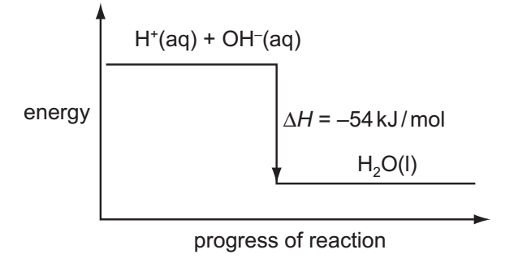
What can be deduced from the diagram?
A Heat is needed to start the reaction.
B The products contain less energy than the reactants.
C The reaction is rapid.
D The OH– ions have more energy than the H⁺ ions.

Your answer
20 The equation shows the reaction for the formation of sulfur trioxide.

2SO₂(g) + O₂(g) qe 2SO₃(g) ∆H = –197kJ

Which change in reaction conditions would produce more sulfur trioxide?
A adding more catalyst
B decreasing the pressure
C increasing the temperature
D removing some sulfur trioxide

Your answer

21 Which substance, when added to water, does not make a solution that is a good
conductor of electricity?
A barium nitrate
B calcium chloride
C lead(II) nitrate
D zinc carbonate

Your answer

22 A simple cell is shown below.
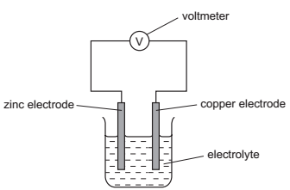

Which statement about the process occurring when the cell is in operation is correct?
A Cu²⁺ ions are formed in solution.
B Electrons travel through the solution.
C The reaction Zn → Zn²⁺ + 2e⁻ occurs.
D Zinc increases in mass.

Your answer

23 The usual conditions for the Haber process are 250 atm pressure, 450°C and an iron
catalyst.
Which change in conditions would give the reactants more energy?
A addition of more catalyst
B a decrease in pressure
C an increase in concentration of the reactants
D an increase in temperature

Your answer

24 Chlorine can be manufactured by the following reaction.
4HCl(g) + O₂(g) → 2H₂O(g) + 2Cl₂(g) ∆H is negative
A mixture in dynamic equilibrium is formed.
Which change to the mixture will increase the amount of chlorine at equilibrium?
A adding a catalyst
B adding more HCl(g)
C decreasing the pressure
D increasing the temperature
Your answer

25 Equations for reactions of iron and iron compounds are shown.
Fe + 2HCl → FeCl₂ + H₂
2FeCl₂ + Cl₂ → 2FeCl₃
FeSO₄ + Mg → Fe + MgSO₄
FeSO₄ + 2NaOH → Fe(OH)₂ + Na₂SO₄
How many of these are redox reactions?
A 1 B 2
C 3 D 4

Your answer

26 Which is a use of sulfuric acid?
A as a bleach
B in the manufacture of ammonia
C in the manufacture of fertilisers
D in the manufacture of sulfur trioxide

Your answer

27 A metal M forms a chloride which dissolves in cold water and has an oxide which dissolves in both strong acids and strong alkalis.
What is M?
A iron B lead
C sodium D zinc

Your answer

28 Which element has a variable oxidation state, can act as a catalyst and forms coloured compounds?
A carbon B iron
C lead D nitrogen

Your answer

29 An atom of which element has the same electronic configuration as the strontium ion?
A calcium B krypton
C rubidium D selenium

Your answer

30 The boiling points of gaseous elements increase as the size of their atoms increases.
Which of these noble gases has the highest boiling point?
A argon
B helium
C krypton
D neon

Your answer

