MCQ A

1 The formula of ammonium sulfate is (NH₄)₂SO₄.
What is the empirical formula of ammonium sulfate?
A NHSO
B NH₂SO₂
C NH₄SO₄
D N₂H₈SO₄

Your answer

2 Which of the following metals is found uncombined in the Earth’s crust?
A aluminium B gold
C sodium D zinc

Your answer

3 Which of these is a mixture?
A chlorine
B sodium
C sodium chloride
D sodium chloride solution

Your answer

4 From the position of beryllium, Be, in the periodic table, beryllium is most likely to be
A a metal
B a halogen
C a compound
D a gas at room temperature

Your answer

5 Which product is formed when there is incomplete combustion of propane?
A sulfur dioxide
B oxygen
C hydrogen
D carbon monoxide

Your answer

6 Which of the following is the formula of a hydrocarbon?
A C₆H₅OH
B CH₂OHCH₂OH
C H₂C=CHCH₂CH₃
D C₆H₁₂Cl₂

Your answer

7 The atomic number of lithium is 3.
The mass number of a lithium atom is 7.
Which row of the table shows the number of protons, neutrons and electrons in
an atom of lithium-7?

 | number of  protons | number of  neutrons | number of  electrons
A | 3 | 3 | 4
B | 3 | 4 | 3
C | 4 | 3 | 7
D | 7 | 4 | 3
Your answer

8 Which of these mixtures shows formulae of substances that could be in the gaseous fraction of crude oil?
A C₂H₄, C₃H₈, C₄H₁₀O
B C₂H₄, C₃H₇Br, C₄H₁₀
C C₂H₆, C₃H₈, C₄H₁₀
D C₂H₆, C₃H₇Br, C₄H₁₀O

Your answer

9 One molecule of decane produced two molecules of propene, C₃H₆, and one molecule of product Z.

C₁₀H₂₂ → 2C₃H₆ + product Z
What is the formula of product Z?
A C₄H₈
B C₄H₁₀
C C₇H₁₄
D C₇H₁₆

Your answer

10 Alkanes and alkenes are hydrocarbons. The structure of a molecule of butane is shown.
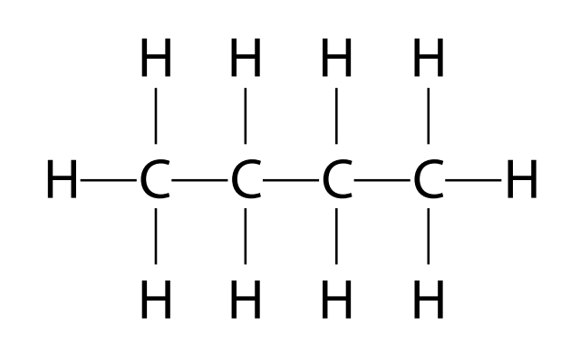
Which of the following is the empirical formula for butane?
A CH
B CH₂
C C₂H₅
D C₄H₁₀

Your answer

11 What type of reaction takes place between butene and steam?
A addition
B dehydration
C neutralisation
D substitution

Your answer

12 When iron reacts with dilute hydrochloric acid, a gas is given off and iron(II) chloride
is formed.
a Which gas is given off?
A carbon dioxide
B chlorine
C hydrogen
D oxygen

Your answer

b What is the formula of iron(II) chloride?
A FeCl B Fe₂Cl
C FeCl₂ D Fe₂Cl₂

Your answer

13 Sulfur trioxide is produced by reacting sulfur dioxide with oxygen.
2SO₂(g)+ O₂(g)qe 2SO₃(g)
What volume of oxygen, in cm³, would react completely with 500 cm³ sulfur dioxide?
A 500 ÷ 2
B 500
C 500 × 2
D 500 × 32

Your answer

14 Why does potassium iodide solution conduct electricity?
A It contains a metal
B It contains electrons which can move
C It contains ions which can move
D It contains water

Your answer

15 What are the products of electrolysing potassium iodide solution?
Product at cathode Product at anode
A hydrogen iodine
B hydrogen oxygen
C potassium iodine
D potassium oxygen

Your answer

16 Which product of the reaction shown is an alkane?
A C₂H₄
B C₃H₆
C C₄H₈
D C₆H₁₄

Your answer

17 The hydrocarbon C₄H₈ was burnt in air. Incomplete combustion occurred.
Which equation, A, B, C or D, correctly represents the incomplete combustion reaction?
A C₄H₈ + 4O → 4CO + 4H₂
B C₄H₈ + 4O₂ → 4CO + 4H₂O
C C₄H₈ + 6O₂ → 4CO₂ + 4H₂O
D C₄H₈ + 8O → 4CO₂ + 4H₂

Your answer

18 Propanoic acid is a carboxylic acid.
Which structure, A, B, C or D, shows propanoic acid?

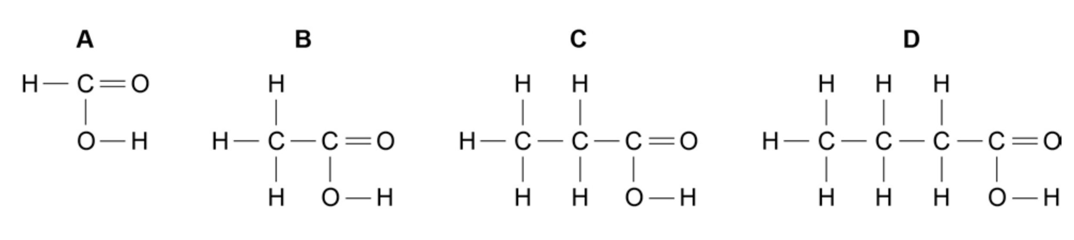

Your answer

19 A student tested a solution by adding aqueous sodium hydroxide. A precipitate was not seen because the reagent was added too quickly.
What could not have been present in the solution?
A Al³⁺
B Ca²⁺
C NH₄⁺
D Zn²⁺

Your answer

20 Which substance has a giant molecular structure at room temperature?
A methane
B sand
C sodium chloride
D water

Your answer

21 When a covalent liquid boils its molecules become more widely spaced.
Which property of the molecules has the most influence on the energy required to boil a covalent liquid?
A the forces of attraction between the molecules
B the reactivity of the molecules
C the shape of the molecules
D the strength of the covalent bonds in the molecules

Your answer

22 The atoms and have the same
A nucleon number.
B number of electrons.
C number of neutrons.
D proton number.

Your answer

23 One mole of a sample of hydrated sodium sulphide contains 162g of water of crystallisation.
What is the correct formula of this compound?
A Na₂S.3H₂O
B Na₂S.5H₂O
C Na₂S.7H₂O
D Na₂S.9H₂O

Your answer

24 The diagram shows the electrolytic production of aluminium.
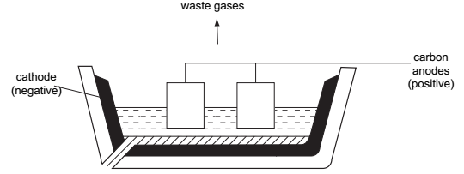
What are the products at the electrodes?
Negative electrode Positive electrode
A solid aluminium hydrogen
B solid aluminium oxygen
C liquid aluminium hydrogen
D liquid aluminium oxygen

Your answer

25 When dilute sulfuric acid is electrolysed between platinum electrodes, which statements are correct?
1 Hydrogen is released at the cathode.
2 Oxygen is released at the anode.
3 Sulfur is released at the anode.
4 The acid becomes more dilute.
A 1 and 2
B 1 and 3
C 2 and 4
D 4 only

Your answer

26 At 400°C the reaction between hydrogen and iodine reaches an equilibrium.
H₂(g) + I₂(g) qe 2HI(g) ∆H = –13kJ
Which change in conditions would increase the percentage of hydrogen iodide in the
equilibrium mixture?
A a decrease in pressure
B a decrease in temperature
C an increase in pressure
D an increase in temperature

Your answer

27 Sulfur dioxide reacts with aqueous bromine according to the following equation.
SO₂(g) + Br₂(aq) + 2H₂O(l) → H₂SO₄(aq) + 2HBr(aq)
Which element has been oxidised?
A bromine B hydrogen
C oxygen D sulfur

Your answer

28 When 20 cm³ of a 2 mol/dm³ solution of potassium hydroxide is mixed with 20 cm³ of a 1 mol/dm³ solution of sulfuric acid, the temperature of the mixture rises.
What best explains this?
A Sulfuric acid is a strong acid.
B The potassium hydroxide solution is more concentrated than the sulfuric acid solution.
C The reactants have a higher energy content than the products.
D Potassium hydroxide is a very strong alkali.

Your answer

29 Which observation is typical of a solid non-metal element?
A It reacts vigorously with chlorine.
B It conducts electricity.
C It has more than one oxidation state.
D It forms an acidic oxide.

Your answer

30 Which equation represents the reaction between hydrochloric acid and sodium hydroxide?
A Cl⁻ + Na⁺ → NaCl
B 2H⁺ + O^{2–} → H₂O
C ½O₂ + H₂ → H₂O
D H⁺ + OH⁻ → H₂O

Your answer

