The Legacy of the Attlee Government and the Post War Consensus

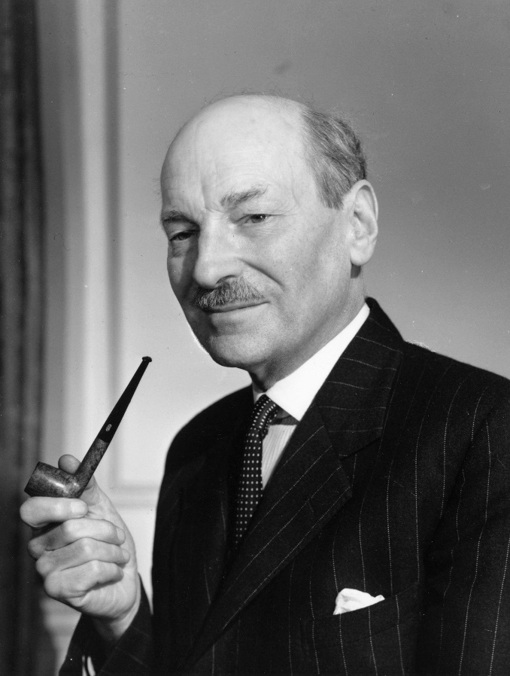 | 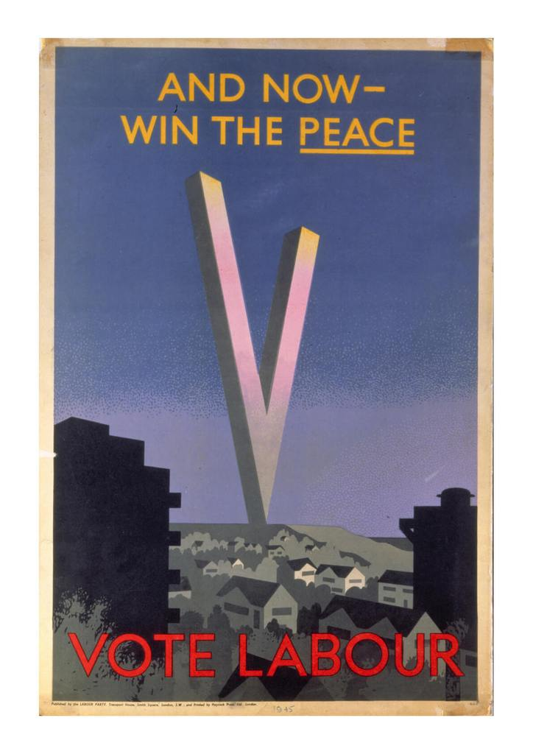
Clement Attlee  Prime Minister 1945-1951 | Labour election poster, 1945

In 1945 Labour won a landslide election victory. It was the first time in its history that Labour had been able to form a government with a majority in the House of Commons. The new government, under Clement Attlee as Prime Minister, introduced a range of policies that set the agenda for post war British politics. These policies included:

- The creation of nationalised industries and the mixed economy. Between 1946 and 1951, several industries including coal, iron and steel, gas, electricity, the railways, road haulage and telephones were brought under state ownership (“nationalised”). This amounted to 20% of British industry and 10% of the workforce. But there was no attempt to go further, with most industry remaining privately run. This is called “the mixed economy”. Underpinning this change was a commitment by the government to ensure full employment. No one wanted a return to the “Hungry Thirties” with its mass unemployment and poverty.
- The creation of the welfare state. The experience of the 1930s with its inequalities (“the haves and the have nots”) and the sacrifices made during the war years to ensure victory meant that there was a determination to secure a better future for the British people. The government was committed to introducing universal state benefits, affordable housing and a National Health Service. Between 1946 and 1951:

  - A series of measures ensured universal (for all) child benefits, unemployment benefits, old age pensions, and extra benefits for the destitute
  - A massive house building programme, partly to replace houses destroyed in the Blitz and to clear Victorian slums. Much of this housing was council housing (houses owned by the local council and rented out)
  - The creation of the National Health Service. This provided free health care, including optical and dental care, to everyone. It was the most popular of the reforms introduced. In 1951, due to spiralling costs, charges for prescriptions was introduced as well as some dental and eye care.

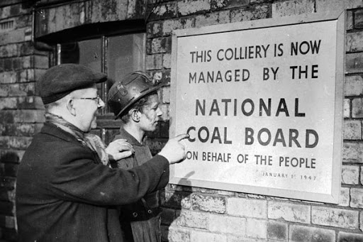 | 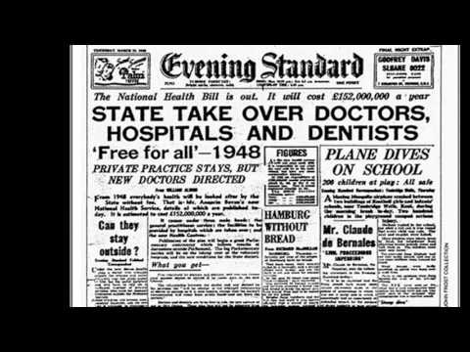
Nationalisation of the Coal Industry, 1947 | The NHS established, 1948

- Cooperation with the Trade Unions. During the war, trade unions had become more powerful and, with the nationalisation of key industries like coal and the railways, the government was keen to keep on good terms with their leaders and members. Prosperity depended on full production for exports and recovery from the war

After 1945 the Conservatives were not in a strong position to oppose these policies. They had long opposed the nationalisation of industry, while they did oppose some of the detail in the setting up of the National Health Service. However, they came to accept the majority of these changes, partly for practical reasons and partly because many in the party came to accept them. After 1951:

- The Conservatives privatised the steel and road haulage industries. They argued that they would be better run and be more profitable under private rather than state ownership. However they left the other nationalised industries alone
- They committed themselves to full employment. The Conservatives were anxious not to be seen as the party of mass unemployment, which was the image they had had in the 1945 election (as they had dominated government in the 1930s)
- The Conservatives could see how popular Labour’s welfare reforms had been especially the National Health Service and were much less hostile to the welfare state
- The Party wanted to continue the harmonious relationship with the Trade Unions
- In 1951, the Conservative majority was slender. The Conservative leadership did not feel in a strong enough position to set about dismantling the Attlee legacy, even if they had wanted to

This broad convergence of policy between Labour and the Conservatives became known as “the post war consensus”. Though there were areas of disagreement and emphasis, it remained in place until the 1970s

“Butskellism”

In 1954, The Economist magazine coined a phrase to describe the measure of consensus between the 2 main parties on economic policy. It was a joining together of the names Butler, Chancellor of the Exchequer, 1951-55 and Gaitskell, Chancellor in 1950-51. Butler, seen as representing the Conservative left and Gaitskell representing the Labour right, seemed to meet in the middle on economic affairs. There were differences: Butler was keen to use interest rates to control the economy while Gaitskell preferred high taxation and greater government direction. But their commitment to “the mixed economy” and the principles of Keynesianism were common.

