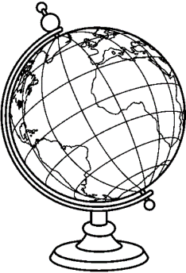
Year 12 Transition Work for Geography
Year 12 Geographers! Great choice of A-level, we look forward to seeing you in September! Hopefully you are ready to get started on a fantastic A-level course where you will have the chance to really enhance your understanding of the world around you. The work in this booklet is designed to help you make the best possible start to the course. Some of it is reviewing and building on work you have done at GCSE, some of it is putting some important basics in place, and some of it is about extending and exploring what is happening in our world.

So you can see how useful this work will be (and so you can follow relevant events in the news), it is important that you are aware of the topics you will cover as part of the A-level Geography course. These are shown in the table below:

Course Topic | Overview of what you will study:
Tectonic Processes and Hazards | The distribution and causes of volcanoes, earthquakes and tsunamis, how to predict and manage them, and specific recent events.
Landscape Systems, Processes and Change (Coasts) | Coastal processes and landforms, coastal ecosystems, climate change and sea level rise, storms and flooding, and managing coastal areas.
Water Cycle and Water Insecurity | Where water comes from, areas of water surplus and water scarcity, issues surrounding sustainable use, inequality and management
Carbon Cycle and Energy Insecurity, Climate Change Futures | Where carbon energy sources come from, energy supplies and politics, sustainable use, carbon emissions, global warming, and alternative energy sources.
Globalisation | Our shrinking world and increasing interconnectedness, industry and its changing locations, de-industrialisation and the post-production countryside, the role of TNCs and globalisation’s winners and losers.
Shaping Places (Regeneration) | Culture, sense of place and identity. The decline of areas and the socio-economic consequences (including indicators of deprivation). Subsequent rebranding, reimaging and investment, and the success and failure of projects from the perspective of different stakeholders.
Superpowers | International and national geopolitics, focusing on the past, present and future role of the USA, the BRICs (Brazil, Russia, India and China) and the UK (the British empire). The types of soft and hard power countries (military, economics and culture).
Global Development (Health, Human Rights and Intervention) | The distribution, indicators and reasons for development and development gaps (between and within countries), particularly focusing on health and human rights, and the resolution of using interventions such as military force/presence, aid and charity.

What do I need to do?

The work is made up of two parts – complete the three sections titled: News Diary, Coasts, Globalisation – This is compulsory.

Pick one task per week from the grid on the next page and complete this, (some of you may have been doing this already).

This is optional but will keep you interested and help with you massively with your learning in September

Optional - Watch at least one video, or read at least one article and then complete one task per week from the grid below based on the reading you have done.
For more resources see the bridging the gap to A Level sheet.
Create a personal geography map of your own area (Harrogate or Leeds)- include photographs, personal reflections and how it may change in the future  (Regenerating Places) | Watch one documentary on Climate Change- Create 20 questions that people could answer if they were to watch the documentary.  https://www.bbc.co.uk/programmes/m00049b1  (Carbon and energy) | Read the essential notes on (Superpowers)  https://pmt.physicsandmathstutor.com/download/Geography/A-level/Notes/Edexcel/7-Superpowers/Essential%20Notes%20-%20Superpowers%20-%20Edexcel%20Geography%20A-level.pdf  Use a timeline to show explain how superpowers have changed over time
Read ‘Changing Cities’- produce a case study summary on one of the cities.  (Regenerating Places) | (Health, Human Rights and Intervention)  Give three ways in which the World Health Organisation (WHO) are helping to control the spread of Coronavirus | Produce a mind map of the multi- hazard area of the Philipines  (Hazards)
In one typed side of A4, explain what ‘geography’ means to you. | Read the Geofile (Coastal Systems, waves, sediments and cells) and summarise on 1 side of A4 paper.  (Coasts) | Water as a resource is the most fought over commodity. To what extent do you agree with this statement?  Read some reading on the Water Cycle and Water Conflicts from resource security to help your answer.  (Water Security)

Compulsory - Current Affairs:

News Diary Task:
You need to be aware of current global events that are related to the units you will be studying. Look out for things in the news to do with the topics we are studying. Use the table on the first page as a guide to topics.
There are many good news websites you can use for free, and others you can subscribe to.

News websites include –
www.bbc.co.uk
www.independent.co.uk
https://www.sciencedaily.com/news/earth_climate/geography/ Is very up to date and very topical.

Most newspapers have downloadable apps, this is a really good way of keeping track of current affairs. The BBC news app even allows you to set up ‘My News’ so you can edit a list of topics. Good topics/key words to add for A-level include: Globalisation, Rebranding, Poverty, Earthquake, Volcano, Tsunami, Development, Human Rights, Economy, Water, Climate, Carbon, Oil and Energy. You can also add specific places or events so you can get updates on useful case studies.

Whenever you notice something on the news that you think links to the Geography you will cover at A-level make a note in the table below. Notes do not have to be detailed, they just need to be a reminder to you.

E.g. May 2019 China-USA trade war. USA imposing trade tariffs on Chinese imports. Meant to be protecting US firms, but US firms end up paying more for the goods from China.

Compulsory - Coasts Task: Coastal Processes and Landforms
There are 4 types of marine erosion. Find a detailed explanation of each:

Corrasion (Abrasion):
………………………………………………………………………………………………...

…………………………………………………………………………......…………………

……………………………………………………………………………………………………………
Attrition:
……………………………………………………………………………………………………………

……………………………………………………………………………………………………………

……………………………………………………………………………………………………………
Corrosion (Solution):
……………………………………………………………………………………………………………

……………………………………………………………………………………………………………

……………………………………………………………………………………………………………
Hydraulic Pressure (Hydraulic Action):
……………………………………………………………………………………………………………

……………………………………………………………………………………………………………

……………………………………………………………………………………………………………

Once material is eroded it is transported along the coast in 4 ways. Find out what solution, suspension, saltation and traction mean. Write and draw a diagram of each in the boxes below.

Traction | Saltation
Suspension | Solution

When material is moved laterally (sideways) along the coast it is called longshore drift. Draw an accurate diagram of how longshore drift works, and write detailed labels to explain each step.

The above are all known as marine processes. This is because they are done by the action of the sea. Some processes occur on the coast that are not done by the sea. These are known as sub-aerial processes and includes weathering and mass movement. Try to find out about the type of weathering and mass movement that happens in coastal areas and create a detailed mind map in the space below:

Sub-aerial processes

Coastal erosion creates different landforms and features. Examples of these include: cliffs, caves, arches, stacks and stumps, and wave cut-notches and platforms.

In the space below, give a detailed description of how a stump is formed.

……………………………………………………………………………………………………………

……………………………………………………………………………………………………………

……………………………………………………………………………………………………………

……………………………………………………………………………………………………………

……………………………………………………………………………………………………………

……………………………………………………………………………………………………………

……………………………………………………………………………………………………………

……………………………………………………………………………………………………………

……………………………………………………………………………………………………………

……………………………………………………………………………………………………………

……………………………………………………………………………………………………………

Now explain the formation of a wave-cut notch and wave-cut platform. Add your own diagrams in the space below:

Explain, using diagrams, how headlands and bays form and change over time.

Headlands and bays can form when differential erosion occurs. Find out what differential erosion means:
..………………………………………………………………………………………………
..………………………………………………………………………………………………
………………………………………………………………………………………………
……………………………………………………………………………………………
Differential erosion is clear to see on discordant coastlines (see diagram below). Explain in your own words how headlands and bays are formed on discordant coastlines:
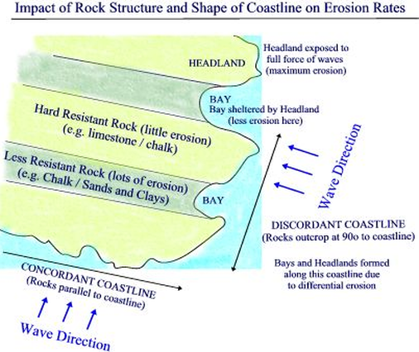
……...…………………………………………
……...…………………………………………
……...…………………………………………
……...…………………………………………
……...…………………………………………
……...…………………………………………
……...…………………………………………
……...…………………………………………
……...…………………………………………
……...…………………………………………
Headlands and bays can also form on concordant coastlines. Find out how this happens and explain in the space below.
……………………………………………………………………………………………………………
……………………………………………………………………………………………………………
……………………………………………………………………………………………………………
……………………………………………………………………………………………………………
……………………………………………………………………………………………………………
……………………………………………………………………………………………………………
A famous example of a coastline. The Isle of Purbeck in Dorset is an example of where a concordant and discordant coastline exist very close to one another. It has a variety of other micro-features and a unique geology. Carry out some research about this stretch of coastline. See if you can answer some of the following questions, and make a note of any other interesting things you find. Keep this information on a separate piece of paper.
- What rocks are found in the area?
- Can you name any of the bays and/or headlands?
- Why else is this area well-known/famous?
- Can you locate the area on a national map?
- Are there any other notable coastal features in this area?
- How would you describe this coastal landscape?

The following are depositional landforms created when the waves deposit sand in a certain way. Fill in the table below:
Sketch | Short description and explanation | Example (name and location)
Spit

Recurved spit

Double spit

Drift-aligned beach

Swash-aligned beach

Offshore bar

Barrier beach (also known as a bar)

Barrier island

Tombolos

Cuspate foreland

Compulsory - Globalisation Task:
The following are questions that you should properly research and write detailed notes in the boxes below. You can display your notes how you want in the spaces, try to make it neat, easy to read and interesting. You should use several sources to construct your answer to each question. There is lots of useful information online, there are some websites below to help you get started.
http://www.coolgeography.co.uk/A-level/AQA/Year%2013/Development%20&%20Globalisation/Globalisation/Globalisation.htm
https://pmt.physicsandmathstutor.com/download/Geography/A-level/Notes/Edexcel/3-Globalisation/Essential%20Notes%20-%20Globalisation%20-%20Edexcel%20Geography%20A-level.pdf
https://geographyrevisionalevel.weebly.com/31a-what-is-globalisation.html
https://www.economicshelp.org/blog/401/trade/what-caused-globalization/
https://www.tutor2u.net/geography/reference/globalisation-benefits-and-costs-of-interdependency
https://intranet.royalhospitalschool.org/geography/pupil-resources/legacy-gcse-2016/year-10-archive-gcse/changing-uk-settlements/case-study-london-docklands
http://www.markedbyteachers.com/as-and-a-level/geography/london-docklands-decline-and-re-generation.html
http://www.cornwallheritagetrust.org/discover/industry-in-cornwall/
http://www.markedbyteachers.com/as-and-a-level/geography/case-study-of-deprivation-in-a-rural-area-cornwall.html
https://www.newstatesman.com/politics/welfare/2016/02/real-cornwall-county-poorer-lithuania-and-hungary

What is globalisation?

What are the causes of globalisation?

What factors have caused globalisation to speed up?

Define the following:
Primary industry

Secondary industry

Tertiary industry

Quaternary industry

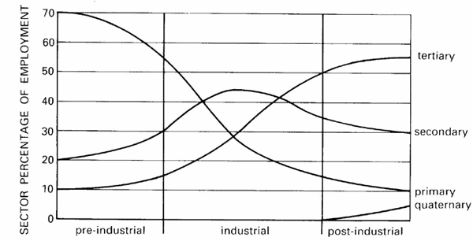
Using the graph, and your own research, describe the changing pattern of industry.

What have caused the changes you described above?

Case Study 1: Changing Industry in The London Docklands
Find out about industry in the London Docklands since the industrial revolution to present. Your research should include a description and explanation of the changing industry in the area. It should include information about the growth of industry in the area in the 1800s, the causes and consequences of the decline of these industries, and any attempts to attract new industry to the area/any regeneration projects from the 1980s to present.

Case Study 2: Changing Industry in Cornwall
Find out about Cornwall since the industrial revolution to present. Your research should include a description and explanation of the changing industry in the area. It should include information about the types of industry in the area in the 1800s, the causes and consequences of decline in these industries, and any attempts to attract new industry to the county and/or regeneration projects since 1990s.

You may also be considering Geography at University: See the following link if you think you may be interested visit: https://www.rgs.org/geography/studying-geography-and-careers/geography-at-university/
Deadline for work : Start of September Term

