NEA 2 Planning Sheet
Key:
- Banana bread
- Bean casserole and sundried tomato bread
- Roasted vegetable Lasagne
Shopping and storage List
Fridge 0-5 ° C | Freezer -18° C | Ambient (room temperature)
100g Unsalted Butter | 50g frozen peas | Bananas
2 red reppers |  | Sundried tomatoes
200g strong plain flour (pasta) |  | 400g can kidney beans
100g strong plain flour (bread)

Equipment and Serving Dishes Required: Colour coded
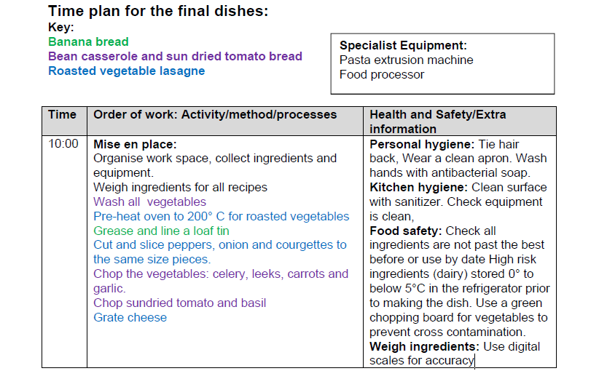
Equipment
Equipment | Serving Dishes & garnish
White chopping board | White rectangular plate
Sharp knife | Icing sugar and sieve
Measuring jug | Slices of banana
Loaf tin | Small wood board
Piping bag and nozzle
Table knife | Rectangular oven proof dish
Food processor | Parsley for garnish
White chopping board
Sharp knife
Flour dredger
Saucepan
Colander
Kettle for boiling water
Pasta machine
Measuring jug | Small soup ball
Baking tray | Round wood board
