Aldosterone
Aldosterone is a ________________________.
It is secreted by the _______________ glands above the kidneys.
Which region of the adrenal glands secretes aldosterone?

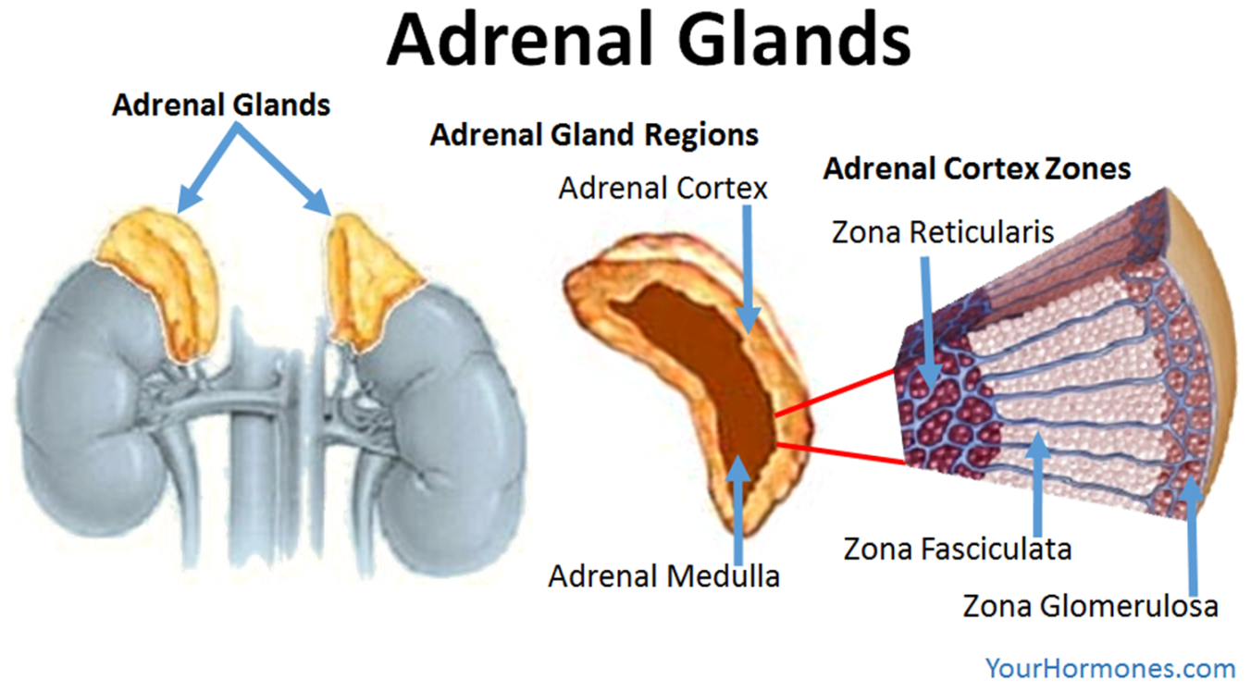

The primary role of aldosterone is the maintenance of a constant level of sodium ions (Na⁺) in the plasma of the blood.
When aldosterone is secreted into the blood the kidneys actively reabsorb sodium ions from the filtrate. As sodium ions are reabsorbed water follows by osmosis into the blood.
Aldosterone also increases the excretion of potassium ions (K⁺).
The release of aldosterone is stimulated by a fall in the volume of the blood.
Find out what happens to the body of there is too much or too little aldosterone released from the adrenal glands – make brief notes

Sodium and the body – research task

What are the short and long-term effects of sodium chloride (salt) deficiency on a person’s health?

Short-term

Long-term

When might a person be at risk of losing too much salt from their body?

Why is too much salt in our diet dangerous to our health?

Which health problems might too much salt cause us?

