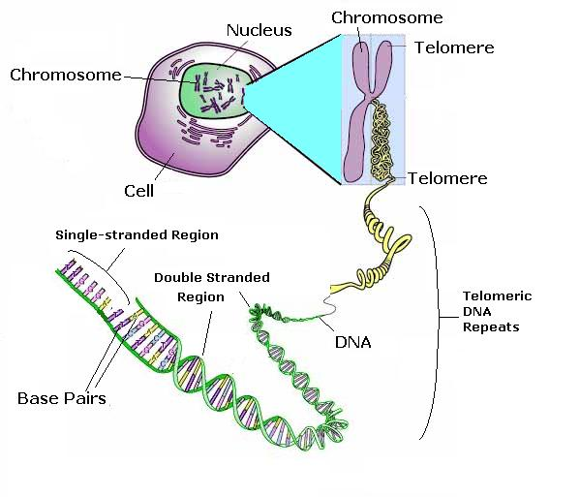
DNA
Chromosomes are made of DNA and contain genes
Inside the ___________ of each of your body cells you have _____________ pairs of ____________________. Each ________________________ is one long coiled molecule of ____________________. Within each DNA molecule, there are shorter sections of DNA – these sections are called ____________________. You inherit half of your genes from your____________________ and half from your____________________. They control our ____________________
Genes mother DNA nucleus
characteristics chromosome father
chromosomes 23 twins
Two people with identical genes are clones of each other. They are identical____________________

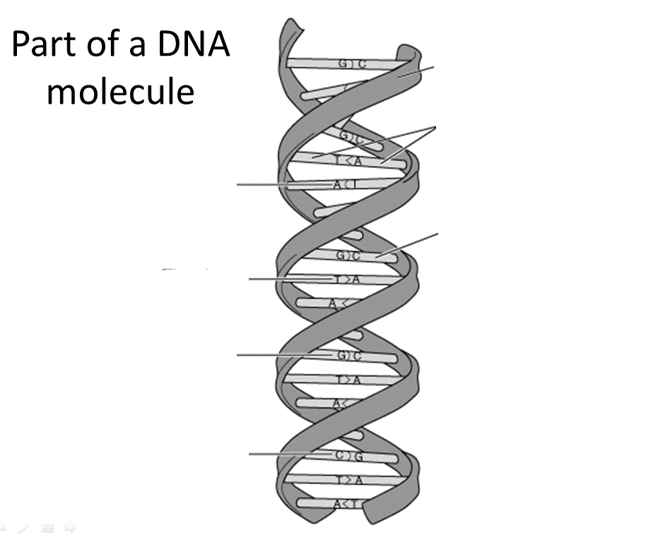
The structure of DNA is described as a _____________ _____________________. There are cross links between the two helices formed by _______________ ____________________.
Each gene has coded __________________ ____________________. This genetic code is formed by the _______________ of ___________ _______________ in a particular length of DNA. Each gene contains a different ____________ of base ___________________. A gene codes for a particular combination of ___________ ________________ that makes a specific (particular) _____________________.
protein double helix genetic information pairs sequence sequence base pairs base pairs amino acids

(HINT: Lots of amino acids make up 1 protein).
A T C G A G C T A
Amino Acid – Amino Acid – Amino Acid
Protein

What does your body need proteins for?

DNA is a polymer. It is made up of lots of small, repeating units called nucleotides
Bases always pair up!
Guanine (G) always pairs with ________________.
Adenine (A) always pairs with ________________.
This is called complementary base pairing.

Draw a section of the DNA molecule that you made (make your chain at least 3 nucleotides long)

