How family life in Spain has changed

Read this text for background information:
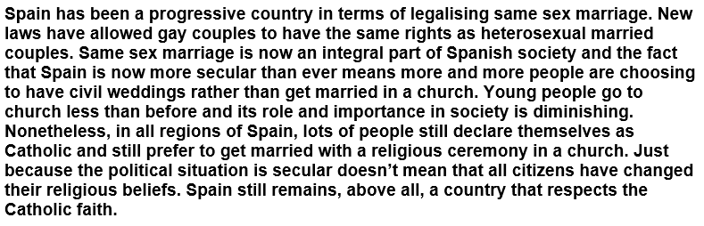

Translate this text into English:
