MCQ C

1 Which industrial process is shown in the diagram?
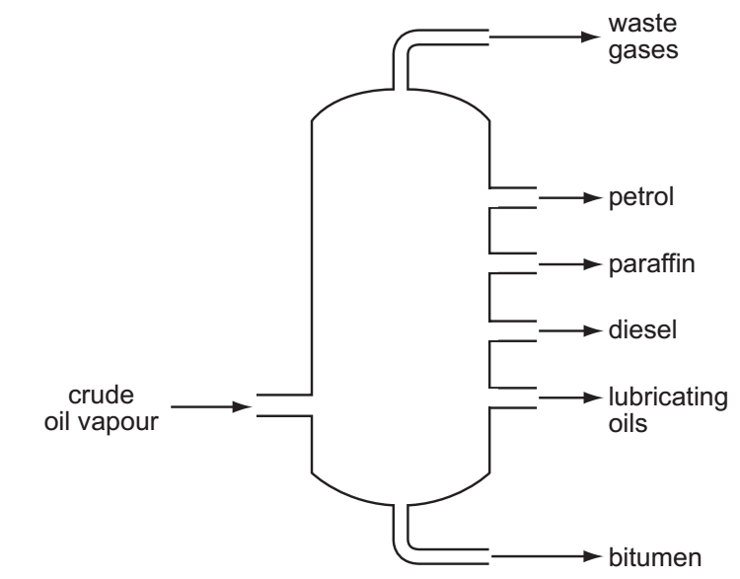
A cracking
B fermentation
C fractional distillation
D polymerisation

Your answer

2 The diagram shows the structures of three compounds.
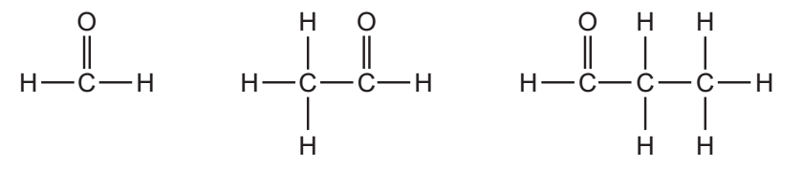
Why do these three compounds belong to the same homologous series?
A They all contain carbon, hydrogen and oxygen.
B They all contain the same functional group.
C They are all carbon based molecules.
D They are all flammable liquids.
Your answer

3 Which method is most suitable to obtain zinc carbonate from a suspension of zinc
carbonate in water?
A crystallisation
B distillation
C evaporation
D filtration

Your answer

4 Which property is shown by all metals?
A They are extracted from their ores by heating with carbon.
B They conduct electricity.
C They form acidic oxides.
D They react with hydrochloric acid to form hydrogen.

Your answer

5 A student investigates how the concentration of an acid affects the speed of reaction
with a 0.5 g mass of magnesium at 30°C.
The student has a beaker, concentrated acid, water and the apparatus below.
P a balance
Q a clock
R a measuring cylinder
S a thermometer
Which pieces of apparatus does the student use?
A P, Q and R only
B P, Q and S only
C Q, R and S only
D P, Q, R and S

Your answer

6 An element Y has the proton number 18.
The next element in the Periodic Table is an element Z.
Which statement is correct?
A Element Z has one more electron in its outer shell than element Y.
B Element Z has one more electron shell than element Y.
C Element Z is in the same group of the Periodic Table as element Y.
D Element Z is in the same period of the Periodic Table as element Y.

Your answer

7 The equation for the reaction between magnesium and dilute sulfuric acid is shown.
Mg + H₂SO₄ → MgSO₄ + H₂
The molar mass of MgSO₄ is 120
Which mass of magnesium sulfate will be formed if 12g of magnesium are reacted with sulfuric acid?
A 5g
B 10g
C 60g
D 120g

Your answer

8 The element vanadium, V, forms several oxides.
In which change is oxidation taking place?
A VO₂ → V₂O₃
B V₂O₅ → VO₂
C V₂O₃ → VO
D V₂O₃ → V₂O₅

Your answer

9 The apparatus shown is used to measure the speed of a reaction.

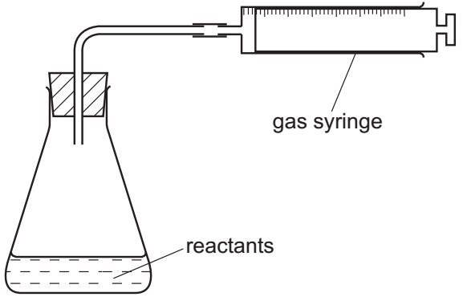
Which equation represents a reaction where the speed can be measured using this
apparatus?
A Mg(s) + 2HCl(aq) → MgCl₂(aq) + H₂(g)
B HCl(aq) + NaOH(aq) → NaCl(aq) + H₂O(l)
C Fe(s) + CuSO₄(aq) → Cu(s) + FeSO₄(aq)
D 2Na(s) + Br₂(l) → 2NaBr(s)

Your answer

10 A gas is escaping from a pipe in a chemical plant.
A chemist tests this gas and finds that it is alkaline.
What is this gas?
]A ammonia
B chlorine
C hydrogen
D sulfur dioxide

Your answer

11 The graph shows how the pH changes as an acid is added to an alkali.
acid + alkali → salt + water
Which letter represents the area of the graph where both acid and salt are present?
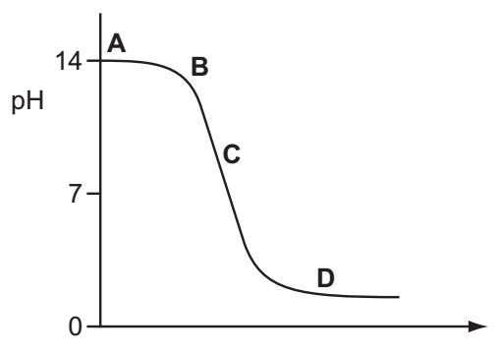

Your answer

12 Which statement about the uses of metals is correct?
A Aluminium is used in the manufacture of aircraft as it has a high density.
B Aluminium is used to make food containers as it conducts electricity.
C Stainless steel for cutlery is made by adding other elements to iron.
D Stainless steel is used to make chemical reactors as it corrodes readily.
Your answer
13 Dilute hydrochloric acid is added to a solid, S.
A flammable gas, G, is formed. Gas G is less dense than air.
What are S and G?
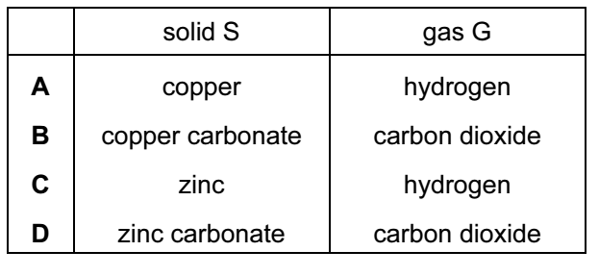

Your answer

14 The diagram shows a section of the Periodic Table.
Which element is described below?
‘A colourless, unreactive gas that is denser than air.’
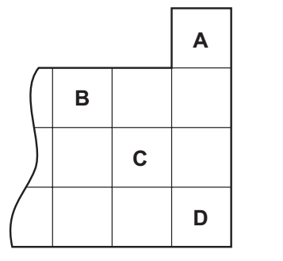

Your answer

15 Element X is below iodine in the Periodic Table.
Which row correctly shows the physical state of element X at room temperature and its reactivity compared with that of iodine?
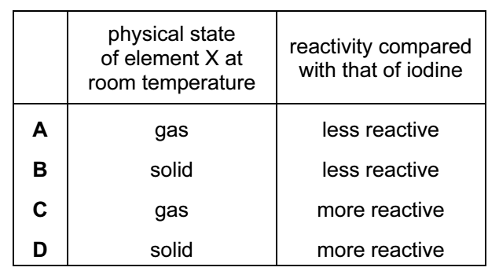

Your answer

17 Five elements have proton numbers 10, 12, 14, 16 and 18.
What are the proton numbers of the three elements that form oxides?
A 10, 12 and 14
B 10, 14 and 18
C 12, 14 and 16
D 14, 16 and 18

Your answer
18 Which properties of the element titanium, Ti, can be predicted from its position in
the Periodic Table?
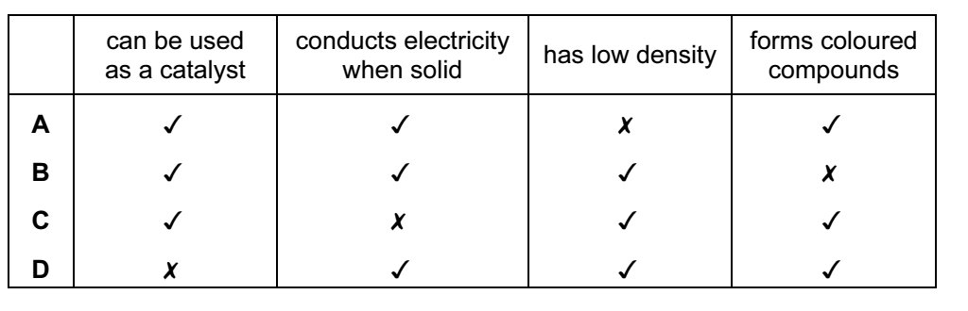
Your answer

19 Which statement about the extraction of iron from its ore is correct?
A Iron is more difficult to extract than zinc.
B Iron is more difficult to extract than copper.
C Iron is easy to extract because it is a transition metal.
D Iron cannot be extracted by reduction with carbon.

Your answer

20 Metal X reacts violently with water.
Metal Y reacts slowly with steam.
Metal Z does not react with dilute hydrochloric acid.
What is the correct order of reactivity of these metals, most reactive first?
A X → Y → Z
B X → Z → Y
C Z → X → Y
D Z → Y → X

Your answer

21 Some uses of water are listed.
1 for drinking 2 in chemical reactions
3 in swimming pools 4 in washing
For which uses is it necessary to chlorinate the water?
A 1 and 2
B 1 and 3
C 2 and 4
D 3 and 4
Your answer
22 Fertilisers need to supply crops with three main elements.
Which compound contains all three of these elements?
A H₃PO₄
B KNO₃
C NH₄K₂PO₄
D NH₄NO₃

Your answer

23 Gas X is a waste gas from digestion in animals.
Gas Y is formed when gas X is burnt with a small amount of oxygen.
Gas Z is formed when gas X is burnt with an excess of oxygen.
What are X, Y and Z?
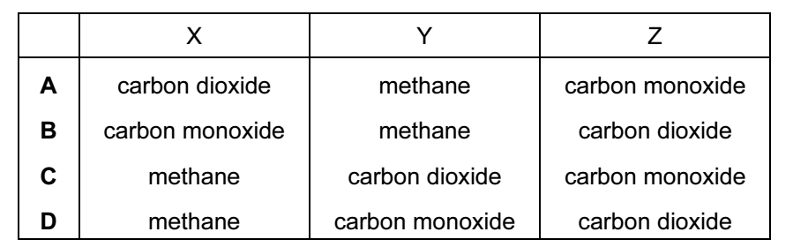

Your answer

24 The structure of a compound is shown.
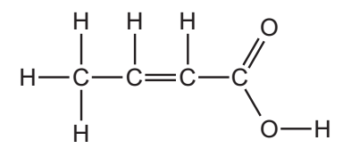
Which functional groups are present in this compound?
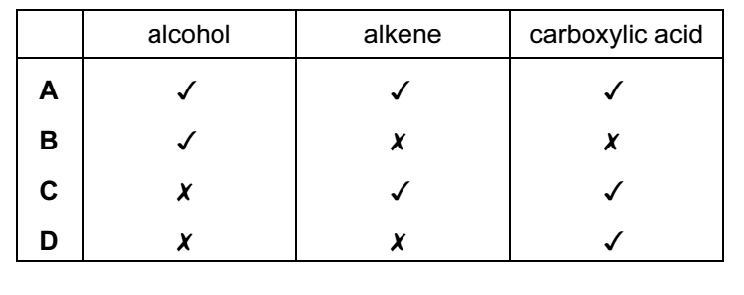

Your answer

25 Which fraction from the fractional distillation of petroleum does not match its correct
use?
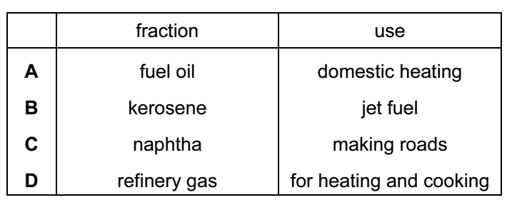

Your answer

26 When a long chain hydrocarbon is cracked, the following products are produced.
1 C₃H₈ 2 C₂H₄ 3 C₃H₆ 4 C₂H₆
Which products would decolourise bromine water?
A 1 and 4 B 2 and 3
C 2 only D 3 only

Your answer
27 The diagram shows apparatus used to separate petroleum into four fractions.
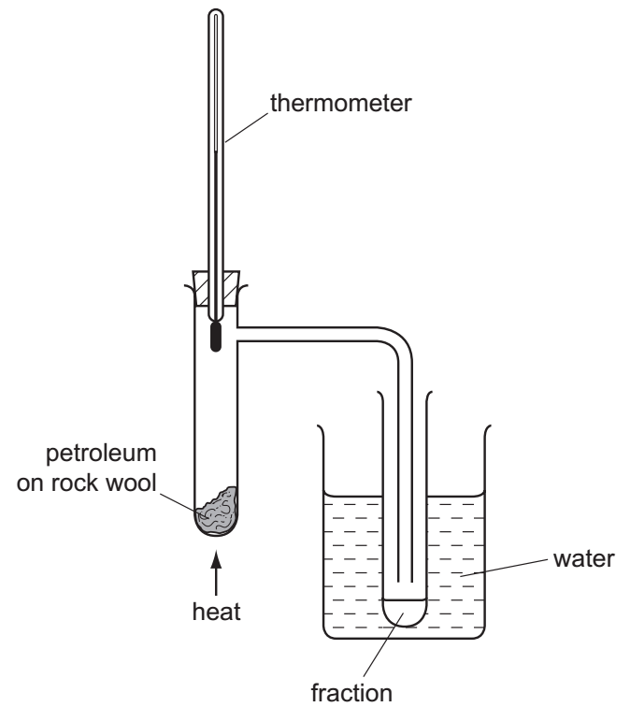
Which fraction contains the smallest hydrocarbon molecules?
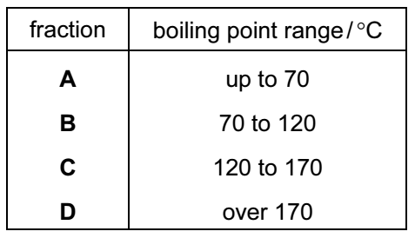

Your answer

28 PVA is a polymer. The monomer has the structure shown.
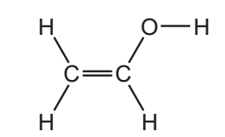
To which homologous series does this compound belong?
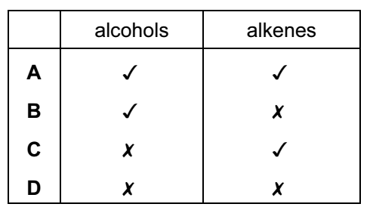

Your answer

29 Which equation represents incomplete combustion of ethane?
A C₂H₆ + O₂ → 2CO + 3H₂
B C₂H₆ + 2O₂ → 2CO₂ + 3H₂
C 2C₂H₆ + 5O₂ → 4CO + 6H₂O
D 2C₂H₆ + 7O₂ → 4CO₂ + 6H₂O
Your answer

30 Ethanol is an important chemical produced by the ……1…… of ……2…… .
Which words correctly complete gaps 1 and 2?

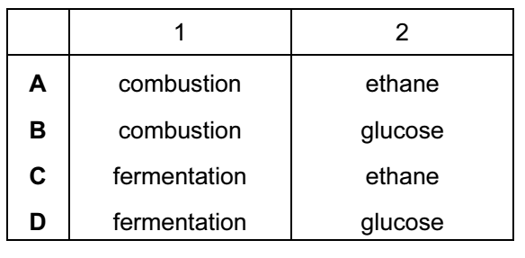
Your answer

