MCQ B

1 The diagram shows part of the Periodic Table.
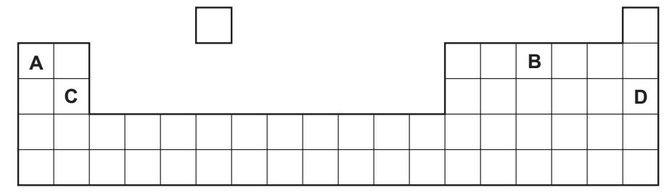
Which element is correctly matched with its electronic structure?
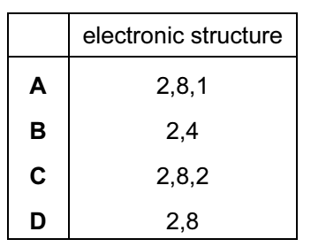
Your answer

2 Electricity from a power station passes through overhead cables to a substation and
then to a school where it is used to electrolyse concentrated hydrochloric acid using inert electrodes.
Which substances are used for the overhead cables and for the electrodes?
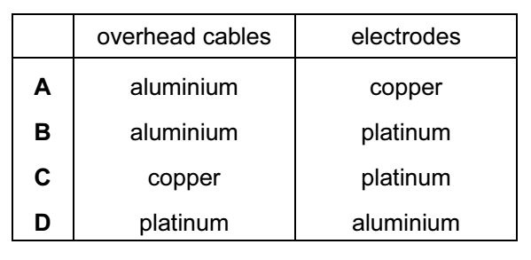
Your answer

3 Electricity is passed through concentrated aqueous sodium chloride, as shown.
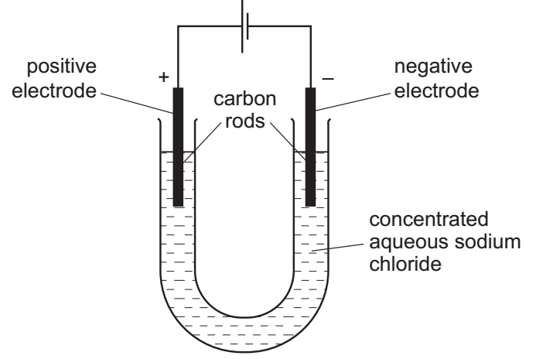
What is the test for the gas formed at the positive electrode?
A bleaches damp litmus paper
B ‘pops’ with a lighted splint
C relights a glowing splint
D turns damp red litmus paper blue

Your answer
4 Butane, ethanol and hydrogen are fuels.
Which substances produce both carbon dioxide and water when used as a fuel?
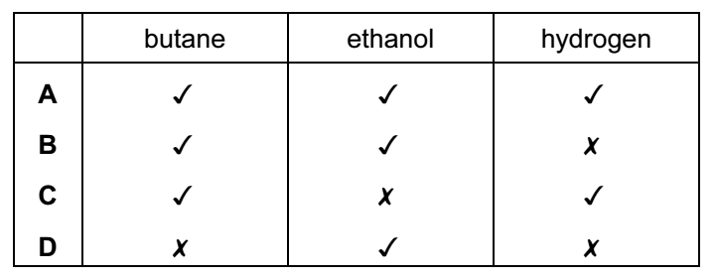

Your answer

5 The apparatus shown can be used to measure the rate of some chemical reactions.
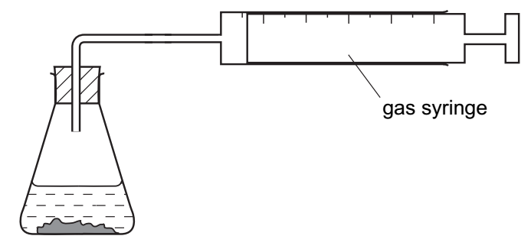
For which two reactions would the apparatus be suitable?
reaction 1 AgNO₃(aq) + HCl (aq) → AgCl (s) + HNO₃(aq)
reaction 2 2H₂O₂(aq) → 2H₂O(l) + O₂(g)
reaction 3 MgO(s) + 2HCl (aq) → MgCl₂(aq) + H₂O(l)
reaction 4 ZnCO₃(s) + 2HCl (aq) → ZnCl₂(aq) + CO₂(g) + H₂O(l)
A 1 and 2 B 1 and 3
C 2 and 4 D 3 and 4

Your answer

6 A student investigates the rate of reaction between magnesium and excess sulfuric
acid.
The volume of hydrogen given off in the reaction is measured over time.
The graph shows the results of two experiments, R and S.
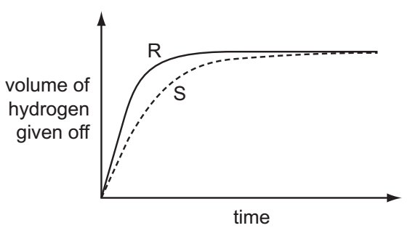
Which change in conditions would cause the difference between R and S?
A A catalyst is added in S.
B The acid is more concentrated in R than in S.
C The magnesium is less finely powdered in R than in S.
D The temperature in R is lower than in S.

Your answer

7 Carbon dioxide is an acidic oxide that reacts with aqueous calcium hydroxide.
Which type of reaction takes place?
A decomposition
B fermentation
C neutralisation
D oxidation

Your answer

8 Which is not a typical property of an acid?
A They react with alkalis producing water.
B They react with all metals producing hydrogen.
C They react with carbonates producing carbon dioxide.
D They turn litmus paper red.

Your answer

9 A solution contains barium ions and silver ions.
What could the anion be?
A chloride only
B nitrate only
C sulfate only
D chloride or nitrate or sulfate

Your answer

10 A mixture containing two anions was tested and the results are shown below.
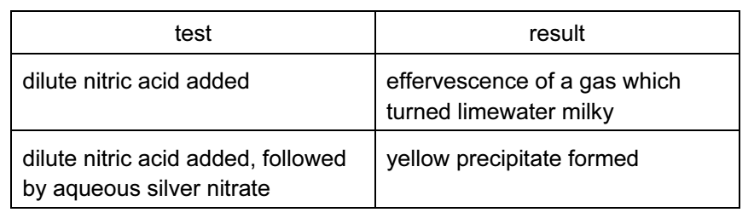
Which anions were present?
A carbonate and chloride
B carbonate and iodide
C sulfate and chloride
D sulfate and iodide

Your answer

11 Which statement is correct for the element of proton number 19?
A It is a gas that dissolves in water.
B It is a hard metal that is not very reactive with water.
C It is a non-metal that burns quickly in air.
D It is a soft metal that is highly reactive with water.
Your answer

12 Brass is an alloy of copper and zinc.
Which statement is correct?
A Brass can be represented by a chemical formula.
B Brass is formed by a chemical reaction between copper and zinc.
C The alloy will dissolve completely in dilute hydrochloric acid.
D The zinc in the alloy will dissolve in dilute hydrochloric acid.

Your answer

13 Water from a reservoir flows to the water works where purification processes 1 takes
Place followed by process 2.
What are purification processes 1 and 2?
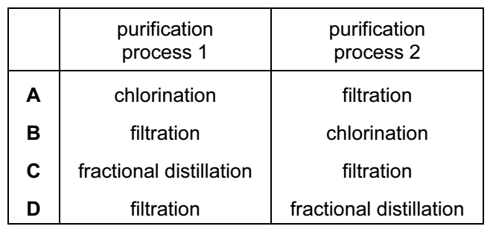

Your answer

14 The table gives the composition of the atmosphere of four newly discovered planets.
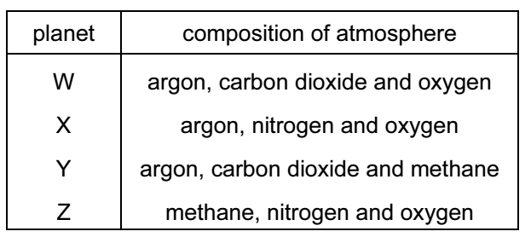
On which planets is the greenhouse effect likely to occur?
A W only B W, X and Z
C W and Y only D W, Y and Z

Your answer

15 Statement 1: Alloying iron with other materials to form stainless steel prevents iron
from rusting by excluding oxygen.
Statement 2: Painting, oiling and electroplating are all methods of preventing iron
from rusting.
Which is correct?
A Both statements are correct and statement 2 explains statement 1.
B Both statements are correct but statement 2 does not explain statement 1.
C Statement 1 is correct but statement 2 is incorrect.
D Statement 2 is correct but statement 1 is incorrect.

Your answer

16 Which two substances, when reacted together, would form a salt that contains two of
The essential elements provided by fertilisers?
A potassium hydroxide and nitric acid
B potassium hydroxide and sulfuric acid
C sodium hydroxide and nitric acid
D sodium hydroxide and sulfuric acid

Your answer

17 What is not essential for the formation of ethanol by fermentation?
A light
B sugar
C yeast
D water

Your answer

18 What is the main constituent of natural gas?
A carbon dioxide
B ethane
C hydrogen
D methane

Your answer

19 Greenhouse gases may contribute to climate change.
Two of these gases are emitted into the atmosphere as a result of processes within animals.
Gas ……1…… is produced by process ……3…… .
Gas ……2…… is produced by process ……4…… .
Which words correctly complete gaps 1, 2, 3 and 4?

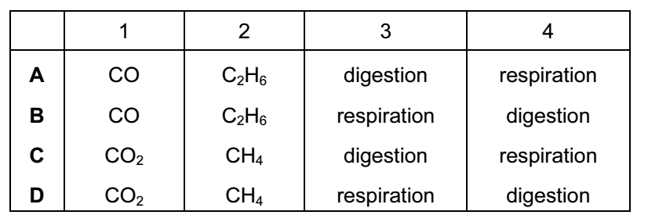

Your answer

20 The equations represent redox reactions.
In which equation is the underlined substance acting as a reducing agent?
A 3CO + Fe₂O₃ → 2Fe + 3CO₂
B CO₂ + C → 2CO
C CuO + H₂ → Cu + H₂O
D CaO + H₂O → Ca(OH)₂

Your answer

21 Compounds containing five carbon atoms in a molecule may have names beginning
with ‘pent…’.
What is the name of the compound shown?
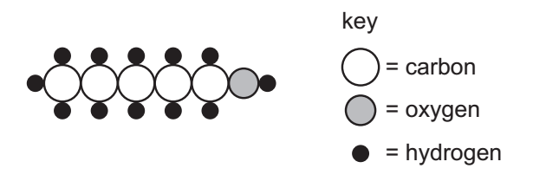
A pentane B pentanoic acid
C pentanal D pentene

Your answer

22 Calcium carbonate reacts with hydrochloric acid to form carbon dioxide.
Which changes would slow this reaction down?
1 decreasing the concentration of hydrochloric acid
2 decreasing the particle size of calcium carbonate
3 decreasing the temperature
A 1 and 2 only
B 1 and 3 only
C 2 and 3 only
D 1, 2 and 3

Your answer

23 Ant stings hurt because of the methanoic acid produced by the ant.
Which substance could, most safely, be used to neutralise the acid?

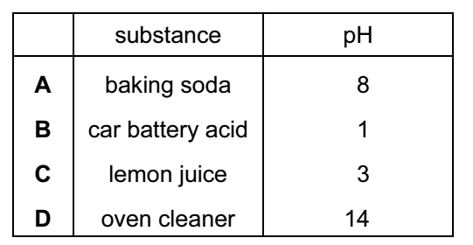

Your answer

24 The diagram shows one period of the Periodic Table
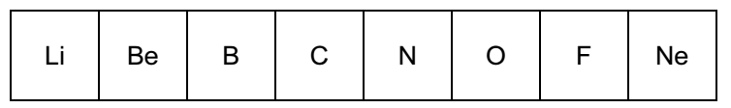
Which two elements form acidic oxides?
A carbon and lithium
B carbon and neon
C carbon and nitrogen
D nitrogen and neon

Your answer
25 Which property of elements increases across a period of the Periodic Table?
A metallic character
B number of electron shells
C number of outer shell electrons
D tendency to form positive ions

Your answer

26 Fluorine is at the top of Group VII in the Periodic Table.
Which row shows the properties of fluorine?
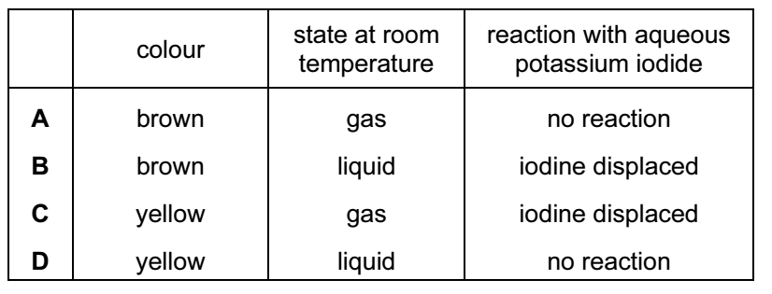

Your answer

27 Group I metals are also known as the Alkali Metals.
Which statement about the metals in Group I is not correct?
A In their reactions they lose electrons.
B Their atoms all have one electron in their outer shell.
C They form +1 ions in their reactions with non-metals.
D They form covalent compounds by sharing electrons.

Your answer

28 Which element is a metal?
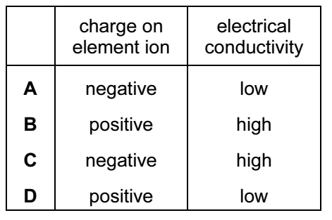

Your answer

29 Which substance is not involved in the extraction of iron from hematite?
A carbon
B carbon monoxide
C calcium carbonate
D nitrogen

Your answer
30 Pure metals conduct electricity and can be hammered into different shapes.
Why are metals sometimes used as alloys?
A Alloys are cheaper than the metals they are made from.
B Alloys are easier to hammer into different shapes.
C Alloys are harder and keep their shape better.
D Alloys conduct electricity better.
Your answer

