MCQ A

1 A student carries out an experiment to find how fast 3 cm pieces of magnesium ribbon dissolve in 10cm³ samples of sulfuric acid at different temperatures.
Which piece of apparatus does the student not need?
A balance
B measuring cylinder
C stop-clock
D thermometer

Your answer

2 Which name is given to mixtures of metals?
A alloys
B compounds
C ores
D salts

Your answer

3 Element X has six electrons in its outer shell.
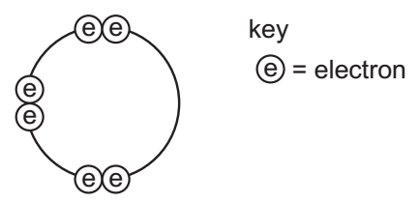
How could the element react?
A by gaining two electrons to form a positive ion
B by losing six electrons to form a negative ion
C by sharing two electrons with two electrons from another element to form two
covalent bonds
D by sharing two electrons with two electrons from another element to form four
covalent bonds
Your answer

4 In which compounds are pairs of electrons shared between atoms?
1 sodium chloride
2 methane
3 lead bromide
A 1 only
B 2 only
C 1 and 3
D 1, 2 and 3

Your answer

5 Hydrogen and chlorine react as shown.
1 molecule of hydrogen + 1 molecule of chlorine → of hydrogen chloride 2 molecules
What is the equation for this reaction?
A 2H + 2Cl → 2HCl
B 2H + 2Cl → H₂Cl₂
C H₂ + Cl₂ → 2HCl
D H₂ + Cl₂ → H₂Cl₂

Your answer

6 The diagram shows apparatus for plating a spoon with silver.
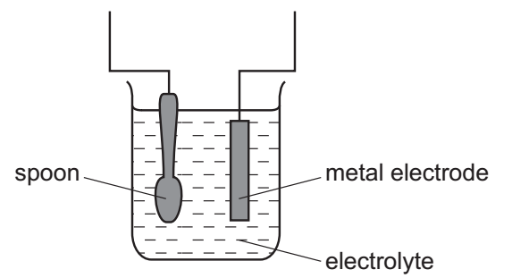
Which statement is not correct?
A Silver would stick to the spoon because it is a very reactive metal.
B The electrolyte would be a silver salt dissolved in water.
C The metal electrode would be made from silver.
D The spoon would be connected to the negative of the power supply.

Your answer

7 Aqueous copper(II) sulfate solution is electrolysed using inert electrodes.
Copper(II) ions (Cu²⁺), hydrogen ions (H⁺), hydroxide ions (OH⁻) and sulfate ions (SO₄²⁻) are present in the solution.
To which electrodes are the ions attracted during this electrolysis?

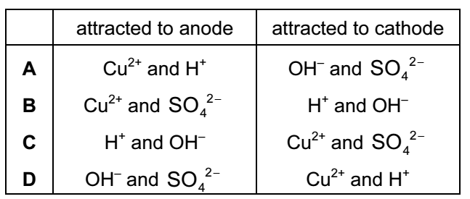

Your answer

8 Three electrolysis cells are set up. Each cell has inert electrodes.
The electrolytes are listed below.
cell 1 aqueous sodium chloride
cell 2 concentrated hydrochloric acid
cell 3 molten lead(II) bromide
In which cells is a gas formed at both electrodes?
A 1 and 2 B 1 and 3
C 2 only D 3 only

Your answer

9 A student investigates the rate of reaction between marble chips and hydrochloric
acid.
The loss in mass of the reaction flask is measured.
The graph shows the results of two experiments, P and Q.
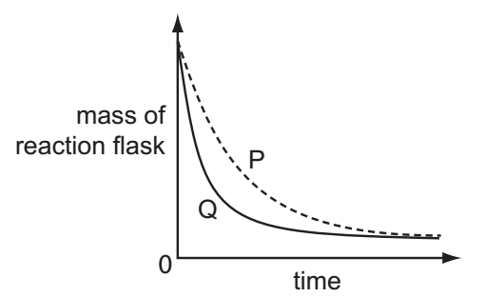
Which change explains the difference between P and Q?
A A catalyst is added in P.
B A higher temperature is used in P.
C Bigger marble chips are used in Q.
D Hydrochloric acid is more concentrated in Q.

Your answer

10 The positions in the Periodic Table of four elements are shown.
Which element is most likely to form an acidic oxide?
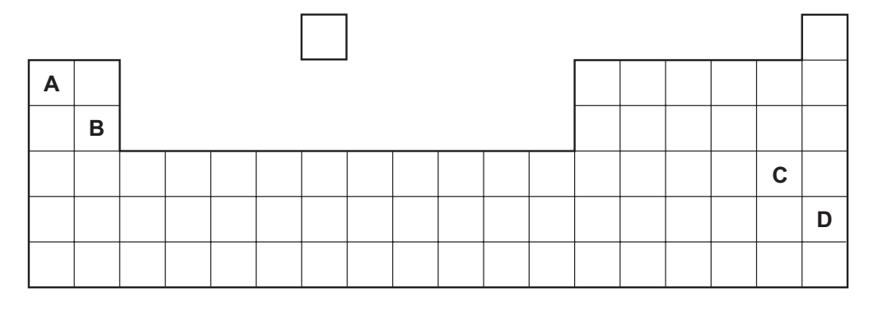

Your answer

11 An excess of copper(II) oxide is added to dilute sulfuric acid to make crystals of
Hydrated copper(II) sulfate.
The processes listed may be used to obtain crystals of hydrated copper(II) sulfate.
1 concentrate the resulting solution
2 filter
3 heat the crystals
4 wash the crystals
Which processes are needed and in which order?
A 1, 2, 3 and 4
B 1, 2, 4 and 3
C 2, 1, 2 and 3
D 2, 1, 2 and 4

Your answer

12 Which is not a property of Group I metals?
A They are soft and can be cut with a knife.
B They corrode rapidly when exposed to oxygen in the air.
C They produce an acidic solution when they react with water.
D They react rapidly with water producing hydrogen gas.

Your answer

13 An element melts at 1455°C, has a density of 8.90 g/cm³ and forms a green chloride.
Where in the Periodic Table is this element found?
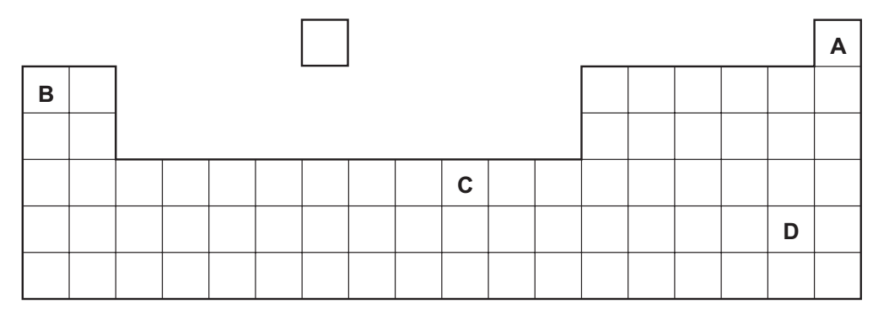

Your answer

14 An element does not conduct electricity and exists as diatomic molecules.
In which area of the Periodic Table is the element to be found?
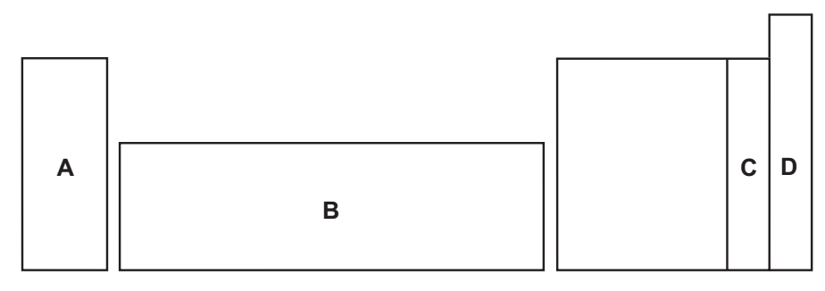

Your answer

15 Solutions of a halogen and a sodium halide are mixed.
Which mixture darkens in colour because a reaction occurs?
A bromine and sodium chloride
B bromine and sodium fluoride
C chlorine and sodium fluoride
D chlorine and sodium iodide
Your answer

16 Which compound in polluted air can damage stonework and kill trees?
A carbon dioxide
B carbon monoxide
C lead compounds
D sulfur dioxide

Your answer
17 Copper, iron and zinc are all used as pure metals.
Which of these three metals are also used in alloys?

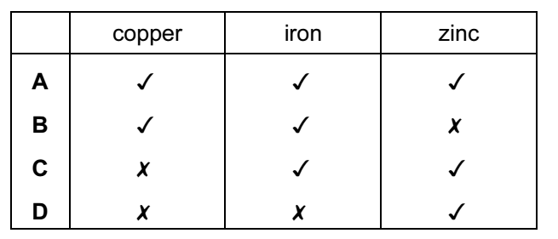

Your answer

18 A student added dilute hydrochloric acid to four metals and recorded the results.
Not all of the results are correct.

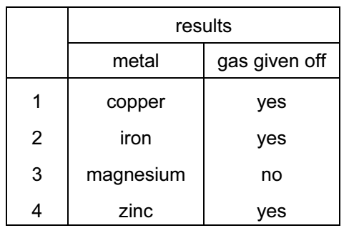

Which two results are correct?
A 1 and 3 B 1 and 4
C 2 and 3 D 2 and 4

Your answer

19 Aluminium is an important metal with many uses. Some of its properties are listed.
1 It is a good conductor of heat.
2 It is a reactive metal.
3 It has a low density.
4 It has an oxide layer that prevents corrosion.
Which set of properties help to explain the use of aluminium for cooking and storing food?
A 1, 2 and 3 B 1, 2 and 4
C 1, 3 and 4 D 2, 3 and 4

Your answer

20 Which statement about the electrolysis of molten lead(II) bromide is correct?
A A colourless gas is seen at the cathode.
B A grey metal is seen at the anode.
C A red/ brown gas is seen at the anode.
D A red/ brown metal is seen at the cathode.
Your answer

21 Which statements about water are correct?
1 Water is treated with chlorine to kill bacteria.
2 Household water may contain salts in solution.
3 Water is used in industry for cooling.
4 Water for household use is filtered to remove soluble impurities.
A 1, 2 and 3
B 1 and 4
C 2, 3 and 4
D 1, 2, 3 and 4

Your answer

22 Which statement about methane is not correct?
A It is a liquid produced by distilling petroleum.
B It is produced as vegetation decomposes.
C It is produced by animals such as cows.
D It is used as a fuel.

Your answer

23 To grow roses, a fertiliser containing nitrogen, phosphorus and potassium is needed.
For the best flowers, the fertiliser should contain a high proportion of potassium.
Which fertiliser is best for roses?
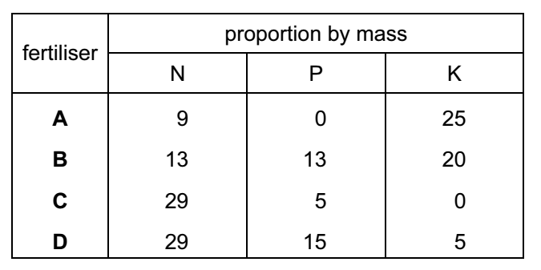

Your answer

24 The diagram shows three types of item.
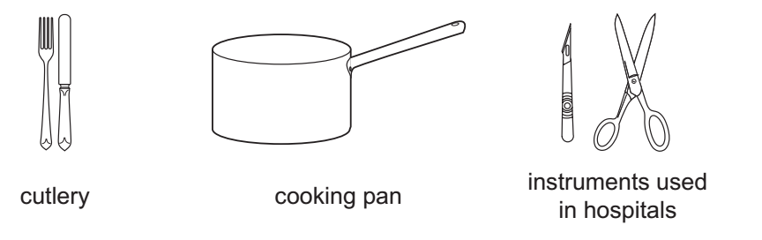
Which method of rust prevention can be used for all three types of item?
A coating with plastic
B covering with grease
C galvanising
D using stainless steel

Your answer

25 Which structure is incorrect?

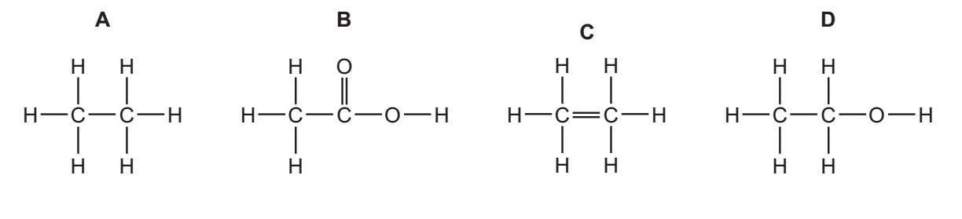
Your answer

26 Which structure shows a compound that belongs to a different homologous series to propane?
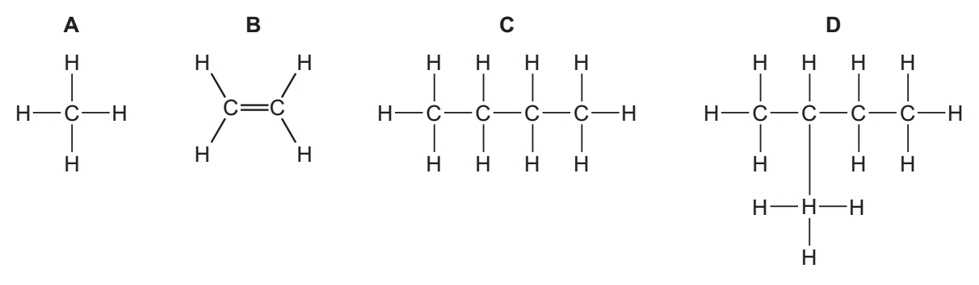
Your answer

27 A macromolecule is a very large molecule.
Macromolecules can be made by joining smaller molecules together. This is called
polymerisation.
Which row in the table describes the formation of a polymer?
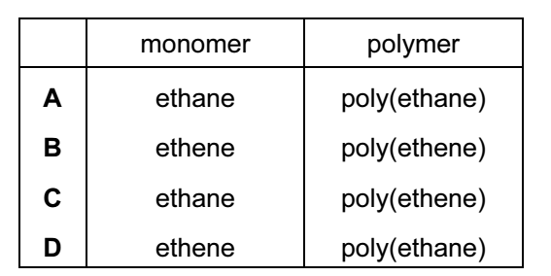

Your answer

28 Diesel, petrol and bitumen are all
A fuels. B hydrocarbons.
C lubricants. D waxes.

Your answer

29 What is the relative molecular mass (M_{r}) of HNO₃?
A 5 B 31
C 32 D 63

Your answer

30 Which two elements react together to form an ionic compound?

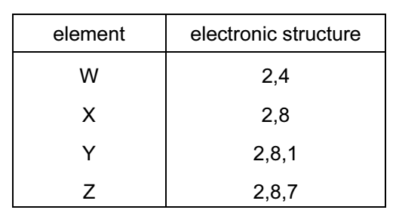
A W and X
B X and Y
C Y and Z
D Z and W

Your answer

