PRODUCTION NEWS
ACTORS, SINGERS, DANCERS WANTED FOR
AN EXCITING AND AMBITIOUS PRODUCTION
OF BERNSTEIN’S MULTI-AWARD WINNING MUSICAL
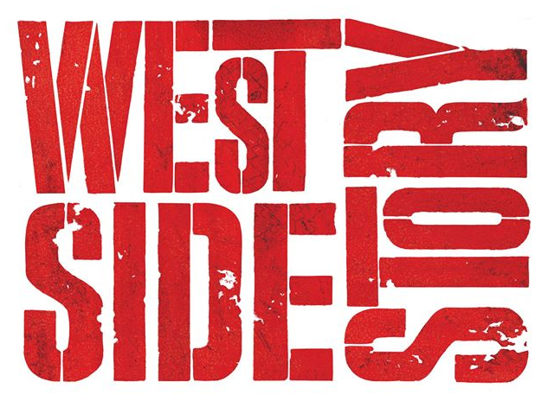
Production dates: Tuesday 22nd – Saturday 26th November 2016
Newcomers to the sixth form are warmly invited to audition following the conclusion of the induction activities on Tuesday 28th June in the St. Aidan’s Drama Studio (next to the Constance Green Hall)

- Prepare 1 minute of a song from any musical that suits your voice and vocal range. Please bring piano music with you.
- You may be invited to take part in brief acting and / or dance workshops. Please wear comfortable clothing.

All parts have yet to be cast so why not give it a go. Please complete the application form overleaf and bring it with you on the day. We look forward to meeting you.

If you require any further information, please email:
Mrs Bray Mr Pallant Ms Miller
Head of Drama Head of Music Head of Dance
f.bray@staidans.co.uk c.pallant@staidans.co.uk s.miller@staidans.co.uk

WEST SIDE STORY NEWCOMERS APPLICATION

PLEASE
ATTACH A PHOTO

PUPIL DETAILS
NAME
MOBILE
PERSONAL EMAIL
N.B Please write carefully. We will contact applicants via email
VOCAL RANGE
(IF KNOWN)
SONG CHOSEN FOR THE AUDITION
SINGING EXAMS – LEVEL ACHIEVED
(IF RELEVANT)
SINGING EXPERIENCE:
E.G. SHOWS, CONCERTS, CHOIR etc.
DANCE EXPERIENCE:
E.G. EXAMS, SHOWS etc.
ACTING EXPERIENCE:
E.G. FESTIVALS, PRODUCTIONS etc.
HEIGHT IN FEET AND INCHES

HAPPY TO SING SOLO

WOULD PREFER TO SING AS PART OF A GROUP

CHARACTER(S) INTERESTED IN:
(FEEL FREE TO LEAVE BLANK)

FOR STAFF USE ONLY:

YOU MUST BRING THIS COMPLETED APPLICATION FORM TO YOUR AUDITION

